CPCS
Child Protection Centres and Services

Progress Report
2015

TABLE OF CONTENTS

Some results at CPCS during the year 2015 (Jan-Dec) 3
With the families… 20
With the children “at risk" 22
With the street children… 22
With the public... 22
With the authorities… 23
With the schools 23
Class programs location details 26
Case studies from the CLASS program 31
Day Field Visits 34
Night Field Visits 35
CPCS legal protection program 36
The emergency line – 44 11 000 38
The CPCS Socialization Shelter 40
Self-management 40
Daily activities and classes 41
The Educational Ticket (ET) System 41
The street banking system 41
Individual lockers 42
The Picnic Program 42
The smoking zone 42
The library 42
Medical Support Program 44
Our Recovery Centre 45
Counseling Services 53
The Rehabilitation center for boys in Dillibazar 56
The Rehabilitation Center for Girls in Godawari 58
The CPCS Schooling Program 60
The Dillibazar Schooling Center for boys 61
Schooling Center for Girls at GODAWARI 63
The Youth Program 65
The CPCS team 69
The CPCS Administration System 70
Networking with Authorities State Bodies and other organization 74
Networking with NGOs and other Child Protection Organizations 75

Introduction
CPCS (Child Protection Centers & Services) has been working on the protection and rehabilitation of street based children and children at risk in Nepal since July 2002. There a numerous reasons that may lead a child to the streets : peer pressure, child agencies, family break-up, poverty, family violence, exploring jobs and education, or urbanization are some examples. Children from poor families migrate on their own from their hometown or village to Nepal’s big cities. Once in the city, they generally end up in the street where they have to face its multiple dangers including drugs, abuses, crimes, hatred, exploitation, discrimination and STD’s.
CPCS runs programs at three distinct levels:
- Prevention (prior to and during the street life) is a set of interventions focused on:
  - Preventing and, if possible, avoiding the arrival of the child in the street, and
  - Raising awareness among the public, families, authorities, school and the children themselves about the realities of street life (its causes, dangers, daily routines and consequences).
- Risk reduction (during life in the street) is a short-term perspective focusing on immediate reduction of the dangers of street life.
- Social rehabilitation (after life in the street) is a mid-term perspective focusing on progressive and eventual reintegration of the child into society and school.

CPCS has three risk reduction and rehab centers in Kathmandu. In the Kathmandu valley, there are elevencenters where CLASS (CPCS Local Action Support and Services) programs are being held. Outside the valley, there are twenty-six other CLASS centers. Up to 1800children receive daily support through our organization’s activities, 300 to 400 children are supported by our socialization or rehabilitation centers, 1400 ex-street-based children and children at risk go to school, and several dozen receive medical or legal support.

Some results at CPCS during the year 2015 (Jan-Dec)
- 1434 children received full scholarship through CPCS prevention programs.
- 500calls were received on the emergency hotline - among them,88 for medical help and49for release from custody.
- 1298 cases of first aid intervention were conducted in the street by the medical team’s outreach activities.
- 1077cases received psychological support through individual & group counseling conducted by CPCS psychological counselors. And 261 times group counsel , 6 sexual abuse cases and 46 cases are physical and moral abuse
- 150 children benefited from legal assistance after they were taken into custody; 63were released after a CPCS intervention and 85children refer from 104
- 21 new children were enrolled to school through the residential schooling programs
- 97 children were reunified with their family from different centers and programs.
- Twochildren were referred to other organizations for training and further support.
- Threeyouths received support to rent a room and seven boys completed SLC.
- 154 cases were referred to various hospitals for OPD checkup, 10 children were admitted to hospitals (where they stayed 219days in total).2807 cases were admitted to our clinic for treatment and 5230 cases visited the clinic for treatment.
- During year 2015, 35 girls ,68 boysnewly entered in rehab Kathmandu and 41 new children entered in rehab Dolakha
In 2015, CPCS received support from several private donors, schools, institutions and organizations. We would like to thank all our collaborators for their contribution and support:
- The American Himalayan Foundation (AHF), USA
- L’Association des Amis de Sœur Emmanuelle, Belgium
- Dynamo International, Belgium
- The Nick Simons Foundation, USA
- SOS Enfants Abandonnés, Belgium
- La Foundation Vieujant, Belgium
- Kinderleven-Vie d’Enfant –ASBL, Belgium
- Ecpat-Luxembourg and the Foreign Affairs Ministry of Luxembourg
- CPCS-France (representing CPCS Alliance in France)
- CPCS-Belgium (representing CPCS Alliance in Belgium)
- Sourires de Katmandou, France
- CARITAS, Belgium

We also received support after the earthquake. Please see this specific part to know more about our partners, donors, individuals who decided to help us. (Page 7)

CPCS’s vision, mission and objectives
Vision:
CPCS works for a society where all children are respected, valued and protected.
Mission:
CPCS’s mission is to deliver basic services (medical, legal, psychological, educational, etc.), in order to bring immediate improvement to street based children and children at risks.
Objectives:
- To develop services directly on the street to offer protection to street based children and to reduce the risks they are exposed to.
- To develop services allowing street based children to take a step forward toward their reintegration into society and into their family.
- To develop prevention programs to prevent more children from coming to the street.
- To take on the children’s problems with understanding and respect, considering them not as victims or delinquents but like people with diverse skills.
- To be a bridge between the street and society.
- To reduce risks that the children face when they are in the street.
- To give the street based children basic education, attention and support.
- To protect the children’s fundamental rights.
- To raise awareness on street children’s situation in Nepal and abroad.
- To give the children access to healthcare and hygiene services.
- To reintegrate the children in their community, and reunite them with their families.
- To reduce and progressively abolish all forms of child exploitation.
- To fight against some of the worst forms of child labor.
- To mobilize communities, organizations, institutions, and families to better meet the children’s needs.
- To contribute to enforcing the Child Act (1992), to provide legal support for children in the streets.

25 Programs/Actions planned for 2015:

- Socialization Shelters facilities for 30 to 50 children daily.
- Informal Education Service: working and meeting on the street with 50 to 70 children and youths daily.
- Other Field Activities: meeting 75-100 children, youths and street adults daily.
- Emergency line 24 hours.
- Clinic - medical care for 200 to 400 children, youths and street adults monthly.
- Counseling - Psychological support for 70 to 100 children monthly.
- Research on issues of abuse and other risk issues.
- Game and activities for 100-150 children daily.
- Cultural Activities for 100-120 children daily.
- Youth Empowerment Programs for 20-40 street youths.
- Family visits and reunification for 30-50 children monthly.
- Schooling Support for 1400 children. (Through “CLASS” program or other programs)
- Public awareness Champaign.
- Socialization-alphabetization classes for 100-200 children daily.
- Creating international awareness about children’s rights and the street children’s situation.
- Local networking and international partnerships.
- Rehabilitation process for 50-80 children and youths yearly.
- Hygiene - clothes distribution for 1200 to 1800 children.
- 50 to 90 safety lockers for working street children. (Street bank).
- Leisure activities as picnics, camps or games in the open.
- Kitchen club - feeding 100-150 children daily.
- Raising children’s self-esteem and awareness about children’s rights, fundamental rights and national law.
- Children library and literacy classes for 200 children daily.
- Child social rehabilitation process. Individual interventions for children and youths.
- Child rights protection programs – security, legal help and court actions.

Earthquakes rescue and relief supports program
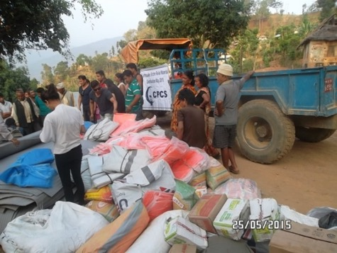
On 25 April 2015, and on 12 May 2015 Nepal faced devastating earthquakes that killed thousands of people. Millions of properties were massively affected and damaged in many parts of the country, mainly in Gorkha, Dolakha, Sindhupalchowk,Kavre, Kathmandu, Dhading, Nuwakot, Sindhuli,Ramechhap, Solukhumbu, Khotang, Okhaldhunga, Rasuwa, Tanhun, Kaski, Chitwan, Makawanpur, Bhaktapur,Lalitpur and Sankhuwasabha. In several of the affected districts; Kavre, Gorkha, Sindhuli, Dolakha, Sindhupalchowk and Ramechhap.
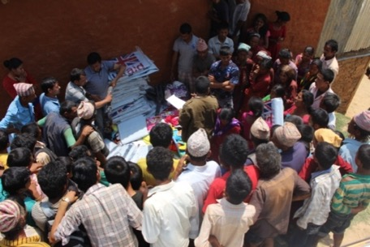
During the earthquakes, people were severelyaffected, they losttheir home, their children, their neighbors, their relatives and family belongings.All the supported children’s families are economically poor, socially underprivileged coming from remote hilly and mountainous areas. To earn some money to survive, they rent rooms in the nearby city areas where they carry on petty work, labor and small business. During the earthquakes, they lost their house in their hometown.
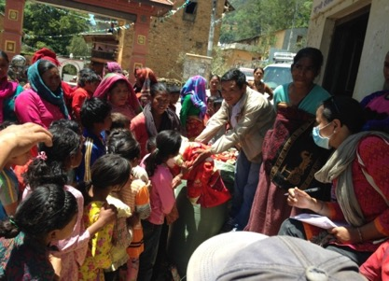
Since April and up to now, CPCS has been helping more than 40 000 persons with different support, depending their situation. Additional help is coming and we are now focusing on metal roof distribution and specific support to schools.
Directly after the earthquakes, CPCS engaged in immediate rescue and relief for those families who were living in massive earthquake-affected districts. The protection of the children living with their families and immediate support for the families was privileged. During earthquake time, what people need the most is shade, which can save their life. For this reason, CPCS distributed tarpaulins and tents to the families who had lost their house.
After the quakes, all the schools had to close and thus the children were out of school. They were terrorized, afraid of quakes and psychologically weak. CPCS launched a displaced children support camp in Dolakha in coordination with government bodies; the District Education Office, the District Administration Office, the District Child Welfare Board and theBhimeshworMunicipality. From 19 May to 31 May2015,there were daily 250 children in the camp. This camp reliefs children from earthquakes fear, terror, trauma and helps the return to regular life though games, art, drawing, sports, dance, music, film and psychosocial counseling. At the same time, CPCS provided meals, tea and snacks for the children.
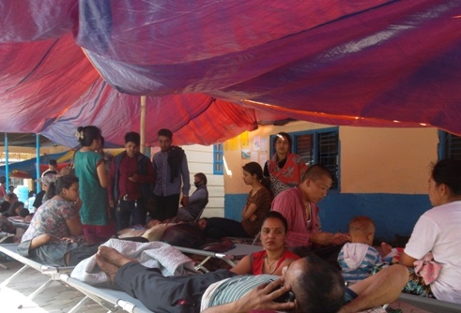
The children and family need to boost up their morale and the children need to counsel and refresh to forget the terror of the quakes and return to normal life.
Regarding the beneficiaries of our support, we do not apply any special selection criteria since allvictims were in need of urgency recovery and support. However, we focus on supported families and CLASS programs existing in the districts. We also try to give support to the other districts as well; Solukhumbu, Khotang, Okhaldhunga, Rasuwa, Tanhun, Kaski, Chitwan, Makawanpur, Bhaktapur, Lalitpur Dhading, Nuwakot and Sankhuwasabha.
We alsoreceive requests from local bodies, municipalities,VDCs, journalist forums, schools and NGO’s for relief materials. In some districts, we visit ourselves and distribute the relief materials to the victims. They provide a written letter with demand for support of relief materials in the affected districts. After the quakes, we have urgently organizedmeetings with our staff and team members to enhance the support and rescue relief activities in the affected districts. At the same time, CPCS inquires about staffs family and home situation. Most of the team members have suffered massively by the earthquakes. After the first quakes on 25 Aprilall, the vendors closed their shops and markets and tried to save their lives. All the traffic halted and there was no mobility of people on the road. During quakes time, we tried to save the children who wherein open space and we sheltered all the CPCS-centers children in safe areas inside the office premises or ground. Some of the staffs wanted to go home to save their family and belongings, so we let them go. Other teams focused on relief materials collection and distribution in out-of-valley quakes-affected areas.
After the earthquakes, all the neighbors gathered at the CPCS premises and took shelter there. We managed a place for them to be safe. We provided them with food, shelter and support.CPCS bought relief material from local markets and stored it. Then we planned to move into disaster areas like Dolakha, Sindhupalchowk, Dhading, Gorkha and Sindhuli. We also contacted our local social actor to get an idea about the situation of the people in the districts. At the same time, we contacted local bodies representatives to speed up the relief work and went directlyto the real stakeholder. There was no exact information or database about the number of victims. In any case, we moved there and distributed relief material through our team. CPCS decided to focus on the distribution of tents, tarpaulins, mattresses, blankets, rice, noodle, water purifiers etc Considering the number of houses that collapsed and causalities, in particular in districts like Dolakha, Gorkha, Sindhupalchowk and Kavre among others.
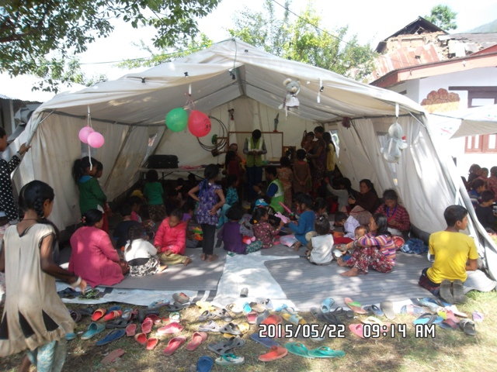
We visited earthquakes sites ourselves and distributed relief materials in the communities. Wecalled the local police, the army, theVDC representative secretary, political parties representative etc... In some of the districts we do nothave, a clear idea about the number of victims so we take assistance from local acquaintances and local body government officers in order to find the right stakeholders and avoid the duplication of reliefprovided. We faced many problems in the districts while distributing the materials. Local people living on the roadside tried to grab the relief materials on the way. This happened mainly in Sindhupalchowk, Kavre and in the Dolakha district. To help us we asked for assistance from thelocal army and the police. Even with their help, there still were people who managed to get away with some materials. In most of the cases, we collectedletter from local representative government bodies, a ward office municipality district development committee and a village development committee. Often, we faced road damage and water shortage. In some cases, we could not buy the materials in the market because of shortage and the pricesincreased immediately. Our central office is in Dillibazar, in the heart of the city and after the quake, all the neighbourcame to us to ask for relief materials. They also tried to attack our team members on duty. There were many neighbors sheltering in our premises and we worked hard to serve them food, water, tea and snacks.

We are very grateful to all our partners who support our relief programs. Since the earthquake, dozens of schools, rotarys, institutions, persons, etc. decided to help us.
Thanks are due to the following persons, institutions and organizations:
Main Working Partners: Caritas, La chaine de l’espoir, Les Amis de Soeur Emmanuelle, American Himalayan Foundation, Simons Foundation, Vrienden van Troje, An and Joris, La communauté de la resurrection. Sukhi Home, IOM,
Working Partners : EU can Aid, SALAAI, Rotary d’Ocquier, Rotary de Bruxelles, L’école de Waltzing, Sourires de Katmandou, INDSE (Bastogne), Le college St Pierre, Molenschool, Dynamo International, Les écoles de Somme-Leuze, Kinderleven-Vie d’enfant, la commission communale de Mohiville, CIMMYT, Abbaye Notre-Dame d’Orval, European School (Luxembourg), PPOT, ZDENKO SPRL, Neve Treck, Louvet Sprl,
We extend our gratitude to all individuals who decided to do something for CPCS, It’s not possible to have an exhaustive list here (so sorry for that) but it includes : Romain Verbeeren, Raymond Ryckmans, Esthel Davidsen, Edwin de boevé, Nicolas Levacq, Pascaline Carnat, Elise Thibault, Jean-Francois Lambert, Chantal Lambert, Filip Janssens, Alessandro Vighi, Jean-Philippe Haleux, Leyla Altmiskara, Christel Crol, Mimi Schoeters, Mampaey-Winters Jan and Elke, Louisa Cummins, Ariane Angenot, Charlotte Magnus, Xavier Laloux, Maertens de Noordhout, Gilles Van Volsem, Aerts Brigitte, Pascale Origier, Pauline Deharre et famille, Duveillier Etienne et , Gautier Stéphanie, Lorin Baptiste, Anne Dorsimont, Justine Desmedt, Barbe Reinhilde, Fabian Cols, Antoon van Dijk, Naomi Koelemans, Geoffrey Luc, Renée Marcourt, Arnoe Céline, Fabienne Origier, Maria Vandeweerd, Plissart C, Elizabeth Delhaise, Bernadette Jacques, Edmon et Monique Petit, Ariane et Julien Radoux, Michel De Brouwer, Brauns Elie, Weynants Mélanie, Plissart de Brandignies, De Reuck Isabelle, Van den Abeele, Desprets B & V, Nadia Van Herck, Bernard Deharre, Philippe Deharre, Ann Heyninck, Ludo Cornelis, Vincent Jehaes, Etienne Gossart, Nathalie Hanssens, Chantal Delfosse, Marchant et d’Ansembour, Rousseau Darquenne, Yves De Cordt, Naudts Anne, Marie Meyer, Jean-François Meyer, Van Weverberg Noortje, Sepulchre Dessy Claudine Broomans, Monique Meur, Monique Blomgren, Sigred BatensSilke Schellekens, Elise Thibault, Ann Balus, Grete Verbist, Clemence Velasc, Marie Jourdain, Nicky Coates, Laetitia Zegers, Victoria O Hana, Natalie Schweizer, Heiko Titsch, Mar de doetinghem, Hans Weening, Michel Pérignon, Benjamin Motteux, Benoit Terreur, Baudoin Van volsem, Christer Sundsmyr, Fréderic Leroux, Michele Maggiolini, Christophe Smets, Guido Declef, Kristin Smart…. And so many others….. (sorry for not being able to mention everyone…. )

Zinc sheet Support for School
SN | School Name | Address | Approx nbr of kids | Nbr of CLASS kids | Qty | Date
1 | Shree Halchok Secondary School | Nagarjun Na Pa - 1, Kathmandu | 300 | 25 | 5 Bundle | 23rd Sept, 2015
2 | Shree Amar Jyoti Secondary School | Ramkot Na Pa -1, Kathmandu | 700 | 30 | 5 Bundle | 14th Sept 2015
3 | Shree Pharping Higher Secondary School | Dakshankali Na Pa - 1, Kathmandu | 450 | 25 | 5 Bundle | 15th Sept 2015
4 | Shree Jana Jagriti Gyan Rasmi Secondary School | Balaju -16, Kathmandu | 450 | 26 | 5 Bundle | 15th Sept 2015
5 | Shree Nandi Secondary School | Naxal - 1 , Kathmandu | 500 | 6 | 5 Bundle | 23rd Sept, 2015
6 | Shree Kshamawati Higher Secondary School | Kshamawari VDC -7 , Dolakha | 400 | 50 | 5 Bundle | 25th Dec, 2015
7 | Shree Buddha Primary School | Kshamawari VDC -8 , Dolakha | 16 | 16 | 5 Bundle | 25th Dec, 2015
8 | Shree Bhuwaneswari Primary School | Kshamawari VDC -8 , Dolakha | 27 | 27 | 5 Bundle | 25th Dec, 2015
9 | Shree Lamanagi Secondary School | Kshamawari VDC -8 , Dolakha | 200 | 100 | 10 Bundle | 25th Dec, 2015
10 | Shree Rajkuleswar Lower Secondary School | Bhimeswar Na Pa - 2 , Dolakha | 150 | 13 | 10 Bundle | 25th Dec, 2015
11 | Shree Tikhatal Primary School | Bhimeswar Na Pa - 2 , Dolakha | 100 | 38 | 5 Bundle | 25th Dec, 2015

Distribution by CPCS of relief material after earthquakes
Districts | Tent | Tarp | Mat | Blanket | Medicine | Rice 30kg | Noodle | Water Purifer | Beaten Rice | Salt | Sugar | Dal | Dignity Packs
Bhaktapur | 3 | 96 | 89 | 38 | 15 | 10 | 240 | 50 | 25 | 20 |  |  | 50
Chitawan |  | 1 | 2 | 1
Dang |  | 1 |  |  | 1
Dhaankuta |  | 1 |  |  | 1
Dhading | 2 | 84 | 30 | 30 | 10 | 5 | 90
Dolakha | 1 | 800 | 625 | 505 | 51 | 85 | 521 |  | 137 | 130 |  |  | 400
Gorkha |  | 46 | 95 | 95 | 4 | 12 | 8 | 2
Gorkha | 20 | 8 |  |  |  |  |  |  |  |  |  |  | 80
Gulmi |  | 1
Kathmandu | 8 | 636 | 478 | 520 | 180 | 140 | 848 | 11 | 150 | 62 | 2 | 2 | 200
Kavre |  | 1 | 2
Kavre | 1 | 182 | 140 | 95 | 28 | 54 | 322 |  | 25 | 10 |  |  | 50
Lalitpur | 2 | 203 | 76 | 41 | 33 | 2 | 15 | 5 |  | 17 | 52 | 27 | 150
Lamjung |  | 2 | 4 | 5 | 2
Makaanpur |  | 3 | 4 | 4 | 2
Makawnpur |  | 1 | 2
Nuwakot | 2 | 80 | 110 | 87 | 9 | 30 | 18 |  |  | 35 |  |  | 150
Okhaldunga | 1 | 5 | 5 | 5 | 3
Palpa |  | 1 | 2 |  | 1
Ramechhap | 2 | 108 | 84 | 37 | 12 |  | 150 | 4
Rasuwa |  | 50 | 30 |  | 1
Shyanja |  | 78
Sinduli |  | 52 | 80 | 80 | 3 |  | 300 | 29
Sinduli |  | 1 |  |  | 1
Districts | Tent | Tarp | Mat | Blanket | Medicine | Rice 30kg | Noodle | Water Purifying pills (box) | Beaten Rice | Salt | Sugar | Dal | Dignity Packs
Sindupalcwok | 5 | 94 | 85 | 153 | 19 | 12 | 8 | 1 | 25 |  |  |  | 100
Solukumbu |  | 41 |  | 2 | 2
Syangja |  | 2 |  |  | 1
Udayapur |  | 1 |  |  | 1
Grand Total | 47 | 2579 | 1943 | 1698 | 380 | 350 | 2520 | 102 | 362 | 274 | 54 | 29 | 377

Prevention Services

Diverse socio-economical reasons lead children to migrate to the street. Eight years ago, CPCS decided to set up prevention programs and awareness activities for families outside and inside of the Kathmandu valley in order to prevent the migration of children to the streets. We developed programs focused on families, children identified as “at risk”, and the public (shopkeepers, police, tourists and the local public, who are indirectly contributing to the marginalization of street children in Nepal.).
Messages and activities adapted to each category of stakeholders have developed and implemented by our organization. For instance, awareness sessions on domestic violence or risks of street life are preferably conducted with the families, while more general awareness sessions on the attitude to adopt when a child is begging for money are conducted with the public.
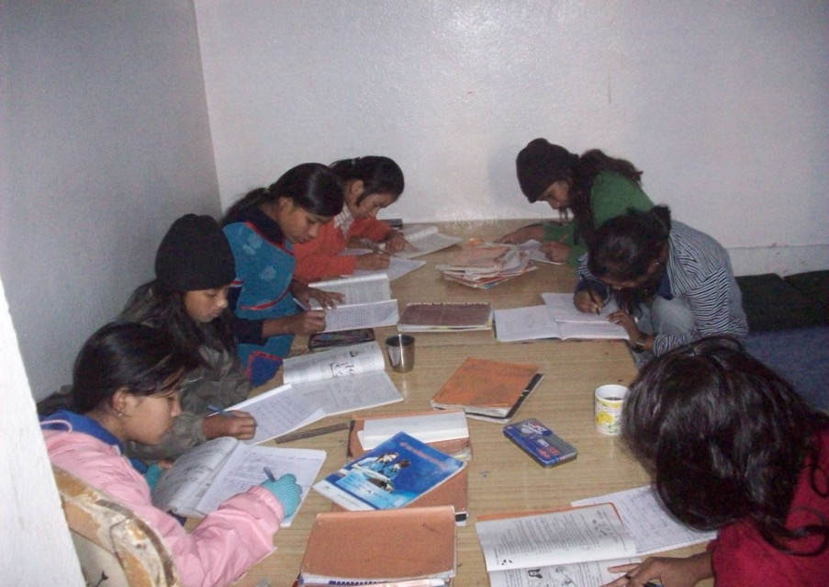
CPCS has also launched a program called CPCS Local Action and Support Services (CLASS). Through presentations, interactive discussions and other related activities conducted with families in the countryside, our teams communicate messages on the right to education, the need for children to attend school, the risk associated with school dropout, and the dangers of the streets in Kathmandu. Altogether4278 parents, schoolteachers and schoolchildren attended CLASS sessions and other related activities organized by CPCS during the year 2015 (Jan –Dec). In 2015, during the year), CPCS prevention teams conducted awareness sessions in Dolakha, Ramechhap, Gorkha, Dhangadi, Surkhet, Butwal, Gorkha, Pharping, Kritipur, Siyuchatar, Halchok, Balaju, Budanilkhanth, Mulpani, Sanothimi, Khowp, Bhaktapur, Jhapa, Birtamod, Itahari, Banepa, Sanothimi,Dhalko, Chalnakhel and Charikot.
Date | Place | children | Parents Teachers | Program
6 Jan 15 | Budhanilkantha | 24 | 4 | Awareness Class and Drawing Class
16 Jan 15 | Lamanagi, Charikot | 32 +40 | 17 | Meeting About New CLASS Program
3 Feb 15 | Mulpani | 29 | 18 | Warm cloth distribution and family meeting
5 Feb 15 | Dolakha | 33+48 |  | Meeting about children studies
22 Feb 15 | Kalanki | 27 | 18 | Awareness Class about personal hygiene and bag distribution.
25 Feb 15 | Kritipur | 31 |  | Drawing class and Awareness about personal hygiene.
1 Mar 15 | Sanothimi | 29 |  | Awareness class about swine flu.
9 Mar 15 | Birtamod | 55 | 34 | Awareness class about swine flu and personal hygiene.
10 Mar 15 | Jhapa | 47 | 41 | Awareness class about swine flu and personal hygiene.
12 Mar 15 | Itahari | 52 | 26 | Awareness class about swine flu and personal hygiene.
20 Mar 15 | Lamanagi | 100 | 16 | Meeting about new class program, children selection, LSA selection.
21 Mar 15 | Deurali | 12 | 7 | Meeting About new class program, children selection, LSA selection.
23 Mar 15 | Kshamawati | 50 | 16 | Meeting About new class program, children selection, LSA selection.
12 Apr 15 | Dhangadi | 27 | 29 | Meeting with kids, parents about his/her study, general health and other topics.
14 Apr 15 | Surkhet | 26 | 19 | Meeting with kids, parents about his/her study, general health and other topics.
15 Apr 15 | Butwal | 32 | 17 | Meeting with kids, parents about his/her study, general health and other topics.
5 May 15 | Kalanki | 26 | 26 | Meeting with parents and relief materials distribution for support kids’ family.
6 May 15 | Pharping | 25 | 32 | Meeting with parents and relief materials distribution for support kids’ family.

Date | Place | children | Parents Teachers | Program
7 May 15 | Budhanilkanth | 15 | 21 | Meeting with parents and relief materials distribution for support kids’ family.
12 May 15 | Halchok | 24 | 35 | Meeting with parents and relief materials distribution for support kids’ family.
13May 15 | Bhaktapur | 24 | 30 | Meeting with parents and relief materials distribution for support kids’ family.
14 May 15 | Kritipur | 50 | 100 | Meeting with parents and relief materials distribution for support kids’ family and other locals.
16 May 15 | Balaju | 15 | 30 | Meeting with parents and relief materials distribution for support kids’ family and other locals.
21 May 15 | Mulpani | 25 | 30 | Meeting with parents and relief materials distribution for support kids’ family and other locals.
8 Jun 15 | Chalnakhel | 25 | 14 | Meeting with children and teacher and collection earthquake effective status.
8 Jun 15 | Pharping | 25 | 9 | Meeting with children and teacher and collection earthquake effective status.
11 Jun 15 | Kritipur | 33 | 45 | Dignity Kit distribution, Health check up, group counseling for kids (Earthquake)
11 Jun 15 | Chalnakhel | 30 | 40 | Dignity Kit distribution, Health check up, group counseling for kids (Earthquake)
11 Jun 15 | Pharping | 28 | 35 | Dignity Kit distribution, Health check up, group counseling for kids (Earthquake)
12 Jun15 | Kalanki | 30 | 36 | Dignity Kit distribution, Health check up, group counseling for kids (Earthquake)
12 Jun 15 | Halchok | 30 | 40 | Dignity Kit distribution, Health check up, group counseling for kids (Earthquake)
12 Jun 15 | Balaju | 26 | 40 | Dignity Kit distribution, Health check up, group counseling for kids (Earthquake)
14 Jun15 | Budhanilkanth | 39 | 45 | Dignity Kit distribution, Health check up, group discuss about Earthquake.
14 Jun 15 | Mulpani | 27 | 35 | Dignity Kit distribution, Health check up, group discuss about Earthquake.
18 Jun15 | Sanothimi | 34 | 45 | Dignity Kit distribution, group counseling for kids and parents about Earthquake.
18 Jun 15 | Bhaktapur | 30 | 45 | Dignity Kit distribution, group counseling for kids and parents about Earthquake.

Date | Place | children | Parents Teachers | Program
19 Jun 15 | Khowp | 25 | 40 | Dignity Kit distribution, Health check up and group counseling for kids and parents about Earthquake.
19 Jun 15 | Dhalko | 23 | 40 | Dignity Kit distribution, Health check up and group counseling for kids and parents about Earthquake.
21 Jun 15 | Dolakha | 500 | 300 | Psychosocial support for children and parents who effected by earthquake.
23 July 15 | Gorkha |  | 55 | Zinc sheet distribution and awareness session about earthquake.
25 July 15 | Chautara | 150 | 50 | Zinc sheet distribution and awareness session about earthquake. Health check up program for kids and parents.
27 July 15 | Balaju |  | 21 | Zinc sheet distribution and awareness session about earthquake.
27 July 15 | Halchok |  | 27 | Zinc sheet distribution and awareness session about earthquake.
27 July 15 | Kalanki |  | 19 | Zinc sheet distribution and awareness session about earthquake.
28 July 15 | Kritipur |  | 14 | Zinc sheet distribution and awareness session about earthquake.
28 July 15 | Pharping |  | 8 | Zinc sheet distribution and awareness session about earthquake.
28 July 15 | Chalnakhel |  | 8 | Zinc sheet distribution and awareness session about earthquake.
28 July 15 | Dhalko |  | 11 | Zinc sheet distribution and awareness session about earthquake.
29 July 15 | Mulpani |  | 13 | Zinc sheet distribution and awareness session about earthquake.
29 July 15 | Sanothimi |  | 12 | Zinc sheet distribution and awareness session about earthquake.
28 July 15 | Budhanilkantha |  | 17 | Zinc sheet distribution and awareness session about earthquake.
30 July 15 | Khwop |  | 24 | Zinc sheet distribution and awareness session about earthquake.
30 July 15 | Bhaktapur |  | 29 | Zinc sheet distribution and awareness session about earthquake.
30 July 15 | Banepa |  | 27 | Zinc sheet distribution and awareness session about earthquake.
7 Aug 15 | Kritipur | 25 |  | Full Damaged office set up and meeting with School management.
7 Aug 15 | Chalnakhel | 25 |  | New CLASS office set up and meeting wth School management and parents.
11 Aug 15 | Khowp | 25 |  | New CLASS office set up.
11 Aug 15 | Sanothimi | 25 |  | New CLASS office set up and meeting wth School management and parents.
19 Aug 15 | Siyuchatar -Kalanki | 25 |  | Full Damaged office set up and meeting with School management.
20 Aug 15 | Halchok | 25 |  | Full Damaged office set up and meeting with School management.
9 Sept 15 | Dolakha | 50 |  | Full Damaged office set up and meeting with School management.
9 Sept 15 | Lamanagi | 100 |  | New CLASS office set up and meeting wth School management and parents.
9 Sept 15 | Kshamawati | 50 |  | New CLASS office set up and meeting wth School management and parents.
9 Sept 15 | Kutidanda | 50 |  | New CLASS office set up and meeting wth School management and parents.
9 Sept 15 | Chautara | 30 |  | Full Damaged office set up and meeting with School management.
9 Sept 15 | Deurali | 17 |  | New CLASS office set up and meeting wth School management and parents
9 Sept 15 | Bhedikhor | 32 |  | New CLASS office set up and meeting wth School management and parents
22 Sept 15 | Banepa | 30 |  | Full Damaged office set up and meeting with School management.
4 Oct 15 | Gorkha | 30 |  | Full Damaged office set up.
1 Nov 15 | Ramechhap | 30 |  | Full Damaged office set up and meeting with School management.
1 Nov 15 | Sindhuli | 50 |  | Full Damaged office set up and meeting with School management.
23 Dec 15 | Balaju | 25 |  | Half-Damaged office set up and meeting with School management.
23 Dec 15 | Budhanilkantha | 25 |  | Half-Damaged office set up and meeting with School management.

CLASS office set up
S. N. | Class Center | District | Office Set Up | Date
1 | CLASS Jhapa | Jhapa | Done | 24th Sep 2015
2 | CLASS Birtamod | Jhapa | Done | 24th Sep 2015
3 | CLASS Itahari | Sunsari | Done | 24th Sep 2015
4 | CLASS Lahan | Siraha | Done | 24th Sep 2015
5 | CLASS Sarlahi | Sarlahi | Done | 24th Sep 2015
6 | CLASS Hetauda | Makawanpur | Done | 24th Sep 2015
7 | CLASS Katari | Udayapur | Done | 24th Sep 2015
8 | CLASS Sindhuli | Sindhuli | Done | 1st Nov 2015
9 | CLASS Narayangadh | Chitawan | Done | 24th Sep 2015
10 | CLASS Butwal | Rupandehi | Done | 24th Sep 2015
11 | CLASS Dhangadi | Kailali | Done | 24th Sep 2015
12 | CLASS Surkhet | Surkhet | Done | 24th Sep 2015
13 | CLASS Gorkha | Gorkha | Done | 4th Oct 2015
14 | CLASS Banepa | Kavre | Done | 22nd Sept 2015
15 | CLASS Dolakha | Dolakha | Done | 9th Sep 2015
17 | CLASS Pharping | Kathmandu | Done | 24th Sep 2015
18 | CLASS Siyuchatar (Kalanki) | Kathmandu | Done | 19th Aug 2015
19 | CLASS Balaju | Kathmandu | Done | 23rd Dec 2015
20 | CLASS Budhanilkanth | Kathmandu | Done | 23rd Dec 2015
21 | CLASS Mulpani | Kathmandu | Done | 24th Dec 2015
22 | CLASS Bhaktapur | Bhaktapur | Done | 24th Dec 2015
23 | CLASS Halchok | Kathmandu | Done | 20th Aug 2015
24 | CLASS Sanothimi | Bhaktapur | Done | 11th Aug 2015
25 | CLASS Chalnakhel | Kathmandu | Done | 7th Aug 2015
26 | CLASS Dhalko | Kathmandu | Done | 19th Aug 2015
27 | CLASS Khowp | Kathmandu | Done | 11th Aug 2015
28 | CLASS Lamanagi | Dolakha | Done | 9th Sep 2015
29 | CLASS Kshamawati | Dolakha | Done | 9th Sep 2015
30 | CLASS Kutidanda | Dolakha | Done | 9th Sep 2015
32 | CLASS Koshi Haraincha | Morang | Done | 19th Nov 2015
33 | CLASS Bayarban | Morang | Done | 19th Nov 2015
34 | CLASS Belbari | Morang | Done | 19th Nov 2015
35 | CLASS - Ramechap | Ramechhap | Done | 1st Nov 2015
36 | CLASS - Chautara | Sindhupalchok | Done | 9th Sep 2015
37 | CLASS - Kirtipur | Kathmandu | Done | 7th Aug 2015
38 | CLASS Deurali | Dolakha | Done | 9th Sep 2015
39 | CLASS Vedhikhor | Dolakha | Done | 9th Sep 2015

Considering the earthquakes damage in Class Centers we provide them cash and kind support catagorizing the damage situation in particularcenters. There is 19 district we have distributed the materials (kind) or cash as well. Among 39 centers, 12 centers got cash 10thousand each and rest other 27 centers got (kind). Four centers got kind equivalent 25 thousand and 23 centers got kind equivalent 50 thousand. There are 19 districtKathmandu, Jhapa, Sindhuli, Sarlahi Msakanpur, Udaypur,Sindhuli, Chitwan, Rupandehi, Kaialai, Surkhet Gorkha, Kavre,Dolakha, Sindhupalchowk, Morang, and Bhaktapur
School Kit's distribution
Sn | School Name | District | CLASS program | kids | Handover | Date
1 | Kalinchok Higher Secondary School | Dolakha | CLASS Charikot | 1100 | Done | 12th Sept 2015
2 | Pashupati Kanya Secondary School | Dolakha | CLASS Charikot | 400 | Done | 12th Sept 2015
3 | Bhim Higher Secondary School | Dolakha | CLASS Charikot | 600 | Done | 12th Sept 2015
4 | Mahendrodaya Higher Secondary School | Dolakha | CLASS Charikot | 500 | Done | 12th Sept 2015
5 | Mathilomati Lower Secondary School | Dolakha | CLASS Charikot | 200 | Done | 12th Sept 2015
6 | Tikhatal Primary School | Dolakha | CLASS Charikot | 100 | Done | 12th Sept 2015
7 | Lapilang Higher Secondary School | Dolakha | CLASS Charikot | 550 | Done | 12th Sept 2015
8 | Bhadrawati Primary School | Dolakha | CLASS Charikot | 65 | Done | 12th Sept 2015
9 | Balmandir Lower Secondary School | Dolakha | CLASS Dolakha | 50 | Done | 12th Sept 2015
10 | Kutindanda Higher Secondary School | Dolakha | CLASS Charikot | 350 | Done | 12th Sept 2015
11 | Kshamawati Higher Secondary School | Dolakha | CLASS Kshamawati | 400 | Done | 12th Sept 2015
12 | Lamanagi Lower Secondary School | Dolakha | CLASS Lamanagi | 200 | Done | 12th Sept 2015
13 | Raj Kuleswor Lower Secondary School | Dolakha | CLASS Dolakha | 150 | Done | 12th Sept 2015
14 | Bhumeswari Primary School | Dolakha | Dolakha Program | 27 | Done | 12th Sept 2015
15 | Buddha Primary School | Dolakha | Dolakha Program | 16 | Done | 12th Sept 2015
16 | Pharping Higher Secondary School | Kathmandu | CLASS Pharping | 450 | Done | 1st Sept 2015
17 | Chalnakhel Lower Secondary School | Kathmandu | CLASS Chalnakhel | 70 | Done | 1st Sept 2015
18 | Adinath Secondary School | Kathmandu | CLASS Kritipur | 340 | Done | 1st Sept 2015
19 | Amarjyoti Secondary School | Kathmandu | CLASS Kalanki | 700 | Done | 3rd Sept 2015
20 | Janajagriti Gyanrasmi Secondary School | Kathmandu | CLASS balaju | 450 | Done | 3rd Sept 2015
21 | Shreeram Lower Secondary School | Kathmandu | CLASS Budhanilkanth | 100 | Done | 7th Sept 2015
22 | Rastiya Nirman Higher Secondary School | Kathmandu | CLASS Mulpani | 600 | Done | 7th Sept 2015
23 | Halchok Secondary School | Kathmandu | CLASS Halchok | 300 | Done | 7th Sept 2015
24 | Mahendra Lower Secondary School | Bhaktapur | CLASS Sanothimi | 180 | Done | 2nd Sept 2015
25 | Ganesh Secondary School | Bhaktapur | CLASS Khowp | 340 | Done | 2nd Sept 2015
26 | Deep Jyoti School | Bhaktapur | CLASS Bhaktapur | 120 | Done | 2nd Sept 2015
27 | Shree Nepal Rastiya Lower Secondary School | Kathmandu | CLASS Dhalko | 100 | Done | 3rd Sept 2015
28 | Nandi Ratri Secondary School | Kathmandu | DB Kids studying School | 500 | Done | 23rd Sept 2015
29 | Bhirkuti Low Secondary School | Gorkha | CLASS Gorkha | 150 | Done | 4th Oct 2015
30 | Amarjyoti Janata Secondary School | Gorkha | CLASS Gorkha | 350 | Done | 4th Oct 2015
31 | Saraswati Primary School | Gorkha | CLASS Gorkha | 150 | Done | 4th Oct 2015
32 | Siddhi Kamala Devi Higher Secondary School | Sindhupalchok | CLASS Chautara | 350 | Done | 9th Sept 2015
33 | Saraswati Primary School | Kavre | CLASS Banepa | 90 | Done | 8th Sept 2015
34 | Janajyoti Secondary School | Kavre | CLASS Banepa | 180 | Done | 8th Sept 2015
35 | Bal Niketan School | Kavre | CLASS Banepa | 380 | Done | 8th Sept 2015
36 | Siksha Sadan Higher Secondary School | Kavre | CLASS Banepa | 420 | Done | 8th Sept 2015
37 | Azad Higher Secondary School | Kavre | CLASS Banepa | 290 | Done | 8th Sept 2015
38 | Chaitanya Higher Secondary School | Kavre | CLASS Banepa | 250 | Done | 8th Sept 2015
39 | Panchakanya Secondary School | Sindhuli | CLASS Sindhuli | 250 | Done | 1st Nov 2015

There are 39 school supported for their school kits and provide 100 and 50 thousand rupees equivalent kind materials for 15 and 24 schools respectively. In kind support, we provide them cupboard, sports materials, chair cushion, table etc. Those school kits is more useful for children holistic development through academic and extra curricualr activties.Those 39 schools are located in seven different districts; Kathmandu, Kavre, Gorkha, Sindhuli, Sindhupalchowk, Dolakha and Bhaktapur. Those schools were affected massively by earthquakes.

School kits distribution programs Kathmandu valley and outskirts
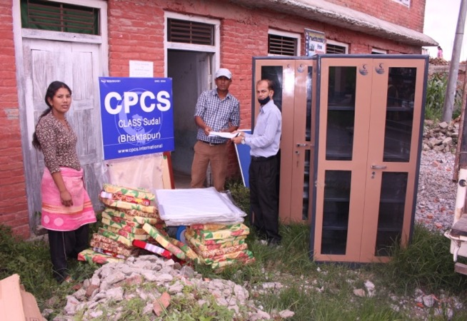

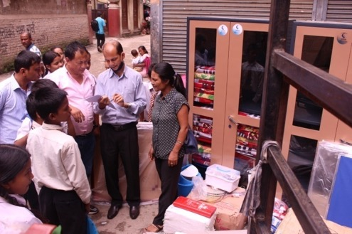
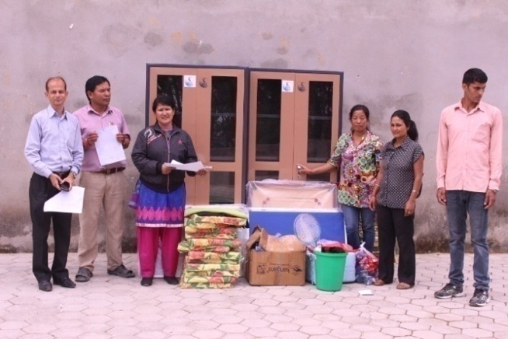

CPCS awareness activities:

With the families…
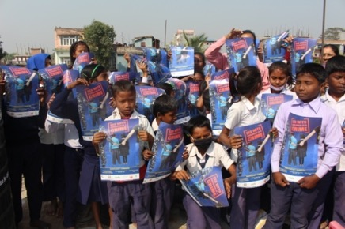
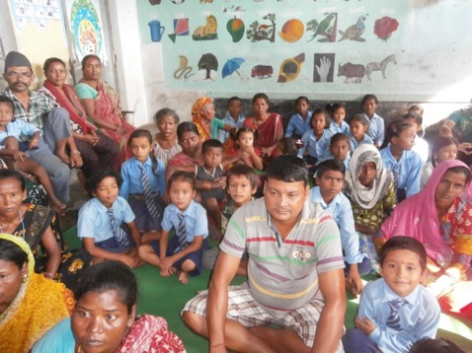
CPCS has been able to collect data and conduct several studies on the topic of street children in Nepal. This has enabled the organization to identify the underlying characteristics of poor households that are likely to lead to the migration of a child to the street. Sometimes, parents themselves are responsible for sending their children to work in the streets and use their child as a source of income. This generally happens when the father loses his job. Other times, alcohol consumption, family break-up or domestic violence can result in children running away from their homes and placing all their dreams in the myth of the city. The relationship with the family is therefore a key element in addressing the issue of street children. Hence, CPCS has developed prevention programs targeted not only at the street children themselves but also at families and children identified as “at risk” by our social workers and their partners (local schools, local organizations, and the authorities).

Prevention programs targets poor families in order to reduce children migration include awareness sessions, family counseling, family mediation services, and the provision for children’s educational costs when necessary (i.e., paying for the tuition fees).Through these activities, we try to make the parents understand that the relationship they have with their children is the best guarantee against the risks of breakdown. Our Educator on-site tries to engage regularly with parents and to address highly sensitive topics such as the rights of the child, duties of the parents, the consequences of domestic violence and alcoholism, hygiene, health, etc.

With the children “at risk"
CPCS educators also involve with children “at risk” in the villages by organizing activities in the local schools. These awareness-raising sessions cover the dangers of the street (drugs, diseases and abuses of all kinds), the rights and duties of parents and children, domestic violence, hygiene, health, the use of illicit substances. Without knowledge of their rights and these risks, the child is an easy prey for a predator.

With the street children…
In Nepal, about 65% of the children who arrive on the street usually stay there. This is why our educators organize regular information sessions in the street to inform the children about the various forms of abuse that street children might be exposed to, i.e. AIDS, drugs, and sexual exploitation. By doing this, we try to make them better prepared to face the dangers. Children in the street and the ones attending our shelters participate in awareness-raising sessions. Without knowledge of these risks, the child is a designated victim. For example, CPCS has launched a campaign on HIV/AIDS, the risks of clandestine sexual intercourse, and the consumption of drugs. We deal with these topics by using posters and other materials, which facilitates communication with the children.

With the public...
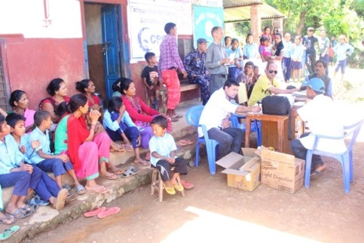
Many different stakeholders interact with street children in Nepal, including the general-public, security forces, shopkeepers, tourist professionals, tourists and schools. CPCS considers that the issue of street children should not only be tackled at the children and their families’ level, but also at the level of these other stakeholders. The image of street children amongst the general public is generally quite negative. Because they wear dirty clothes, use bad language and deny most social norms, they are considered social parasites, young criminals and drug addicts. Children often feel that they have no other choice but to live outside society and reject most of its rules. They form a parallel society with its own codes, its own language and its own rituals, which often include consumption of illicit substances. This leads to a vicious circle: society rejects street children because they are non-social and children are non-social because society rejects them. By working on the general public’s perception of street children, CPCS is trying to break this vicious circle. CPCS believes that “the greater the public’s participation, the greater the chances that children reintegrate society smoothly”
In addition to information sessions, held in order to raise the public’s awareness, our team organizes street dramas and produces short movies. These tools inform the locals on how children are surviving in the street. Street drama enables them to express their experiences freely and reduces the distance with the general public. CPCS has also produced two movies, “Beli 1” (2008) and “Beli 2” (2009) featuring Nepali street children in their everyday life situation. The actors are both CPCS children and professional actors. This awareness tool’s purpose is to awake the Nepalese population to the reality of the street and give it keys to understanding. Lastly, we have adopted a specific policy with regard to the right to one's image. We do not allow people from the outside to use the pictures taken at CPCS as they wish. CPCS prohibits the use of denigrating pictures of street children and the publication of pictures of children’s faces without their consent. By doing this, we intend to respect the rights of the child and set an example for others to follow.

With the authorities…
The police can also be a partner in the fight that CPCS is leading. Firstly, police officers who are badly informed about children’s rights and street children’s living conditions might behave unlawfully towards children and notably use violence against them. By informing the police, we can expect a better understanding and a more humane attitude. Secondly, working in collaboration with the police on the problems of the street is key to our work. Our objective is to calm tenseness between the police and the children. Today, thanks to a good relationship with CPCS, the police is giving preference to calling our hotline rather than incarcerating children in the case of offences. On our side, we try to explain to the child that certain behaviors are harmful to their image and make it necessary for the police to intervene.

With the schools
CPCS organizes street dramas on children’s rights, sexual abuse of children, family violence, education and other abuses. These street dramas are performed in various schools in Kathmandu and in other parts of the country too. Parents, teachers, community people, civil service employees and students are the target audience. The actors are from the CPCS Centers.

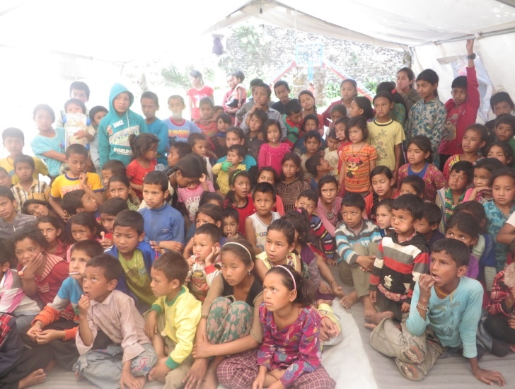

CPCS Local Action and Support Services (CLASS)
CPCS believes that prevention programs should also conductoutside of the valley to address the issue of street children at its source.
Through CPCS Local Action and Support Services (CLASS), CPCS conducts prevention interventions in 28 places outside the Katmandu valley: Jhapa, Birtamod, Itahari, Lahan, Katari, Sindhuli, Sarlahi, Hetauda, Narayangarh, Butwal, Dhangarhi, Surkhet, Gorkha, Banepa, Chautara, Ramechhap, Charikot and Dolakha.
These places were selected after a study showed that those places are the ones that the majority of street children come from, notably because the major roads pass by these towns.
Altogether, 1334 children have been supported directly through the CLASS programs; over 1700 have been supported indirectly through our program.
With the support of a CPCS social worker (locally recruited), CPCS identifies families at risk. The identification process is conducted through networking with other child protection NGOs based in the area, local schools and government bodies. A proposal is offered to the selected families. The CPCS LSA plays the role of a mediator between the school, the family and the child itself.
CPCS provides financial support to the family for school related expenses (monthly fees, exam fees, uniforms, books, stationary etc…), support to the child (which they usually do not get at home due to illiteracy and lack of education in their family).
The CPCS social worker also works as a social counselor trying to install or re-install, through dialogue, a better communication between the family members.
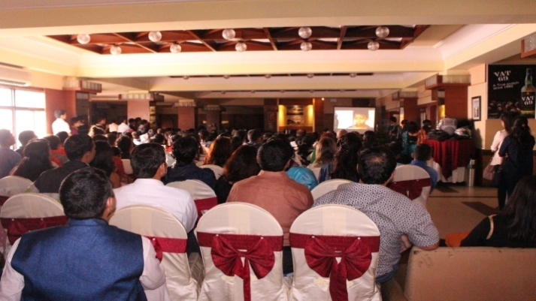
More generally, the CLASS program is raising awareness among ordinary people and stakeholders outside and inside the Kathmandu valley area. At the same time, CPCS’s presence in eighteen different districts of Nepal enables us to get a better overview on the street children’s situation across all of Nepal.

CLASS PROGRAM NUMBER OF SUPPORTED CHILDREN: JAN-DEC 2015
sn | Class | District | Region | J | F | M | A | M | J | J | A | S | O | N | D
1 | Jhapa | Jhapa | East | 50 | 50 | 50 | 50 | 50 | 50 | 50 | 50 | 50 | 50 | 50 | 50
2 | Birtamod | Jhapa | East | 50 | 50 | 50 | 50 | 50 | 50 | 50 | 50 | 50 | 50 | 50 | 50
3 | Itahari | Sunsari | East | 50 | 50 | 50 | 50 | 50 | 50 | 50 | 50 | 50 | 50 | 50 | 50
4 | Lahan | Siraha | East | 45 | 45 | 45 | 45 | 45 | 45 | 45 | 45 | 45 | 45 | 45 | 45
5 | Katari | Udayapur | Central | 30 | 30 | 30 | 30 | 30 | 30 | 30 | 30 | 30 | 30 | 30 | 30
6 | Sindhuli | Sinduli | Central | 50 | 50 | 50 | 50 | 50 | 50 | 50 | 50 | 50 | 50 | 50 | 50
7 | Sarlahi | Sarlahi | Central | 30 | 30 | 30 | 30 | 30 | 30 | 30 | 30 | 30 | 30 | 30 | 30
8 | Hetauda | Makawanpur | Central | 30 | 30 | 30 | 30 | 30 | 30 | 30 | 30 | 30 | 30 | 30 | 30
9 | Narayangdh | Chitawan | Central | 50 | 50 | 50 | 50 | 50 | 50 | 50 | 44 | 44 | 40 | 40 | 40
10 | Butwal | Rupandehi | Western | 50 | 50 | 50 | 50 | 50 | 50 | 50 | 50 | 50 | 50 | 50 | 50
12 | Dhangadi | Kailali | F. West | 30 | 30 | 30 | 30 | 30 | 30 | 30 | 30 | 30 | 30 | 30 | 30
13 | Surkhet | Surkhet | M. West | 30 | 30 | 30 | 30 | 30 | 30 | 30 | 30 | 30 | 30 | 30 | 30
14 | Gorakha | Gorakha | Western | 23 | 23 | 23 | 23 | 23 | 23 | 23 | 23 | 23 | 23 | 23 | 23
15 | Banepa | Kavre | Central | 22 | 22 | 22 | 22 | 22 | 30 | 30 | 30 | 30 | 30 | 30 | 30
16 | Chautara | Sndupalchok | Central | 30 | 30 | 30 | 30 | 30 | 30 | 30 | 30 | 30 | 30 | 30 | 30
17 | Ramechhap | Ramechhap | Central | 30 | 30 | 30 | 30 | 30 | 30 | 30 | 30 | 30 | 30 | 30 | 30
18 | Dolakha | Dolakha | Central | 50 | 50 | 50 | 50 | 50 | 50 | 50 | 50 | 50 | 50 | 50 | 50
19 | Charikot | Dolakha | Central | 101 | 101 | 101 | 101 | 101 | 101 | 100 | 100 | 100 | 100 | 100 | 100
20 | Dillibazar | Kathmandu | Central | 9 | 9 | 9 | 9 | 9 | 9 | 4 | 4 | 4 | 4 | 4 | 4
21 | RSS | Kathmandu | Central | 25 | 25 | 25 | 25 | 25 | 25 | 25 | 25 | 25 | 25 | 25 | 25
22 | Pharping | Kathmandu | Central | 25 | 25 | 25 | 25 | 25 | 25 | 25 | 25 | 25 | 25 | 25 | 25
23 | Kritipur | Kathmandu | Central | 25 | 25 | 25 | 25 | 25 | 25 | 25 | 25 | 25 | 25 | 25 | 25
24 | Siyuchatar | Kathmandu | Central | 25 | 25 | 25 | 25 | 25 | 25 | 25 | 25 | 25 | 25 | 25 | 25
25 | Halchok | Kathmandu | Central | 25 | 25 | 25 | 25 | 25 | 25 | 25 | 25 | 25 | 25 | 25 | 25
26 | Balaju | Kathmandu | Central | 25 | 25 | 25 | 25 | 25 | 25 | 25 | 25 | 25 | 25 | 25 | 25
27 | Budanilkant | Kathmandu | Central | 25 | 25 | 25 | 25 | 25 | 25 | 25 | 25 | 25 | 25 | 25 | 25
28 | Mulpani | Kathmandu | Central | 25 | 25 | 25 | 25 | 25 | 25 | 25 | 25 | 25 | 25 | 25 | 25
29 | Bhaktapur | Bhaktapur | Central | 25 | 25 | 25 | 25 | 25 | 25 | 24 | 24 | 24 | 24 | 24 | 24
30 | Chalnakhel | Kathmandu | Central | 25 | 25 | 25 | 25 | 25 | 25 | 25 | 25 | 25 | 25 | 25 | 25
31 | Dhalko | Kathmandu | Central | 25 | 25 | 25 | 25 | 25 | 25 | 25 | 25 | 25 | 25 | 25 | 25
32 | Sanothimi | Bhaktapur | Central | 25 | 25 | 25 | 25 | 25 | 25 | 25 | 25 | 25 | 25 | 25 | 25
33 | Khowp | Bhaktapur | Central | 0 | 0 | 0 | 25 | 25 | 25 | 25 | 25 | 25 | 25 | 25 | 25
34 | Lamanagi | Dolakha | Central | 0 | 0 | 0 | 0 | 100 | 100 | 100 | 100 | 100 | 100 | 100 | 100
35 | Kutidanda | Dolakha | Central | 0 | 0 | 0 | 0 | 50 | 50 | 50 | 50 | 50 | 50 | 50 | 50
36 | Kashmawati | Dolakha | Central | 0 | 0 | 0 | 0 | 50 | 50 | 50 | 50 | 50 | 50 | 50 | 50
37 | Deurali | Dolakha | Central | 0 | 0 | 0 | 0 | 16 | 16 | 16 | 16 | 16 | 16 | 16 | 16
38 | Vedikhor | Dolakha | Central | 0 | 0 | 0 | 0 | 32 | 32 | 32 | 32 | 32 | 32 | 32 | 32
39 | Koshi Haraincha | Morang |  |  | 0 |  | 0 | 0 |  | 0 | 0 | 50 |  | 50 | 50
40 | Belbari | Morang |  |  | 0 |  | 0 | 0 |  | 0 | 0 | 25 |  | 25 | 25
41 | Byarban | Morang |  |  | 0 |  | 0 | 0 |  | 0 | 0 | 25 |  | 25 | 25

Class programs location details

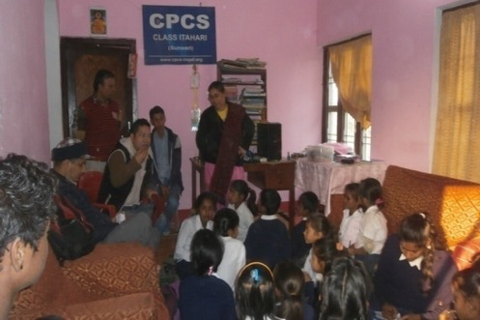
Itahari – (Sunsari District)
Itahari is a famous city in the eastern part of Nepal. Located in the Terai, it constitutes a central point for migrants who are coming from the eastern hills of Nepal to search for work. Thanks to the CLASS program, 50 children of different communities (untouchables and low castes, mostly from migrant labor families) have been enrolled in Janata Higher Secondary school, Itahari. Most of these supported families are landless and live in the slum areas. As a result, many of the supported children collect wear, tear, and waste materials in the street during school vacation.

Charikot – (Dolakha District)
For economic and financial reasons, most of the children in this district are not enrolled in school and are involved in household chores. Through the Charikot CLASS program, 100 children have been supported and enrolled in school. Through the Dolakha CLASS Program, CPCS has been supporting 50 children from lower castes. Since CPCS has started to support these families, the children have been attending classes on a daily basis. The supported schools are Bhim Higher Secondary, Bhadrabati Primary, Tikhatal Primary, BalMandir, Kalinchowk Higher Secondary, Mahendroday Higher Secondary and PashupatiKanyaMandir Secondary.

Sindhuli – (Sindhuli District)
50 children from low caste families have been supported through the CPCS Sindhuli CLASS program. Economic conditions in the village are poor. Most of the people are farmers working six months a year in the village and then looking for work outside their village for the remaining months.

Katari – (Udayapur District)
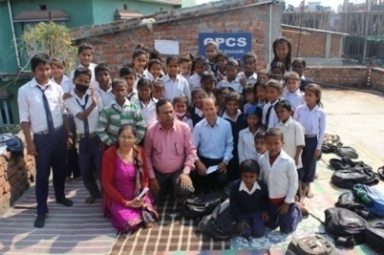
Katari is situated 350 km away from Kathmandu. People living in this village are mostly involved in agricultural work and live in small huts by the riverside. Through the CLASS program, CPCS has been supporting the education of 30 children of poor and low caste families, mostly migrants. The children attend Tribeni Higher Secondary school.

Gorkha – (Gorkha District)
A CLASS program has been implemented in the Gaikhur village. Most children are from low caste Dalit families. This program was set up in 2007 and the program now supports23 children. They are enrolled in four different schools.

Lahan – (Siraha District)
The majority of the population belongs to the unprivileged Madheshi community. 40children are supported through the CPCS CLASS program. Most of the children are from this community but some are also from the untouchable groups and other “lower” castes. Our program is going well there and all the families are grateful for our support.

Narayanghad – (Chitwan District)
This is the junction-city between eastern and western Nepal on the way to the capital. Within this district, there is a large number of migrants from other districts. Most of them are daily wagers or rag pickers. 40 children from marginalized communities and families in need have been supported through our CLASS program. Most of the supported families are landless and some of them live in the slum areas. Some of the supported children collect metals and plastics on the street, usually after attending classes as well as during school vacation. Many families also work on the street.

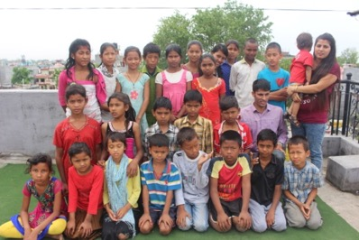
Butwal – (Rupandehi District)
In this big city, a large number of families, mostly migrants from the surrounding hilly districts, live in slums on the bank of the Tinau River. A few years ago, the Tinau River flooded over the slum and they faced great problems. It was almost impossible to stay there. Through the CLASS program, 50 children have been enrolled in Kalika Higher Secondary School.

Sarlahi – (Sarlahi District)
Sarlahi is a plain area (Tarai) in the eastern part of Nepal on the banks of the Baghmati River. A large flood affected Sarlahi in the summer of 2009. Since then, families have been living in extreme conditions preventing them from sending their children to school. 30 children from different castes have now been supported through our program. The children are enrolled in Shree Haturbhujesar Janata Higher Secondary School and Shree Primary School, Ghurkauli.

Surkhet – (Surkhet District)
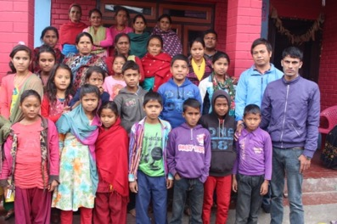
There are many Dalit family children living in Surkhet, a mid-hilly area, CPCS supports 30 children through its program, mostly from untouchable families who migrated from surrounding villages and districts. Our program is running smoothly in Surkhet. Schools and local communities are cooperative and the children are enrolled in HariDilBhumi Secondary School.

Banepa – (Kavre District)
Banepa is also the major trade route to Tibet, crossed by one of the largest highways of the country. Even though it is a small town, Banepa is the major economic center East of Kathmandu. In Banepa, CPCS has been supporting 30 children, mainly from migrant households surviving thanks to daily wages and farming.

Chautara – (Sindhupalchook District)
Chautara is the district headquarters of the Sindhupalchowk district in the central region of Nepal. Although this district is close to the capital, it is one of the less developed of the country. Most of the people are dependent on agriculture for their survival. As there is not enough work, many of them go to Kathmandu to find work. In Chautara, 30 children are being supported by the CLASS program where almost all children come from Dalit communities. The children are studying in Shree SiddhiKmala Devi Higher Secondary School.

Ramechhap – (Ramechhap District)
Its economy is mostly based on agriculture and its population includes several castes and ethnicities. 30 children have been enrolled in the CLASS program through the CPCS intervention. All the children and their families belong to low castes that have migrated to Ramechhap from other districts. All the children are studying in Shree Manthali Higher Secondary School.

Hetauda – (Makawanpur District)
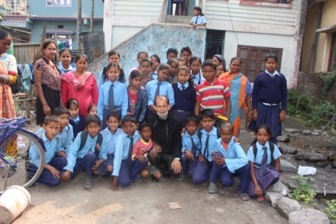
Hetauda is one of the main industrial cities of Nepal located in the Makawanpur district on the bank of the Rapti River. By car from the capital, it takes 4 hours to reach the Makawanpur headquarters. Its population is made up of people from diverse ethnic and economic backgrounds. 30 children benefit from the CLASS program, all from very poor and low caste families. Supported children are studying in Shree Laxmi Lower Secondary School, Hatiya, Makawanpur.

Jhapa (Jhapa District)
Most parents work in a landlord’s home through bondage labor. They take advance loans from the landlord and pay back through labor. These groups’ culture is very ancient yet most of them do not own their own land, have citizenship or have access to education. As a result, most of the people from these ethnic groups are illiterate and unaware of what education can do for them. Most of the children from this group spend their time playing or supporting their parents living in very bad conditions (hygiene, etc.). In these communities, when boys reach 16 years of age, most of them go to India to work while the rest of them work in nearby landlord homes as helpers. Birtamod – (Jhapa District)
CLASS program has been supporting 50 children in Shree Devi Higher Secondary School, BirtamodBazar. Most of the families are from Muslim ethnic groups. They migrated a long time ago either from India or from other parts of Nepal. Most of them pull Rickshaws in the Birtamod market and live in slum areas. Almost all the children’s parents are uneducated.

Class Dhangadi (Kailali District)
It is the regional headquarters of the far western region. Therefore, there are a large number of migrant workers from different communities and remote mid-hill areas. 30 children have been enrolled in school through the CPCS CLASS program in Dhangadi. Most of the children’s families live in the slum area and are from the Tharu community. Children are sent to Shree Navadurga Primary school, Durga Primary school and ChhoingGumba Primary school.

The Residential Support Program (RSS Kathmandu)
The Residential School Support Program covers 25 children living in Kathmandu with their families. Most of them belong to families who have migrated from rural parts of Nepal (due to poverty, natural disasters, searching for a job, etc.) and are earning money to survive as daily wagers, laborers, street vendors or rag pickers. RSS supports children to remain in their home while being supported to go to school. All of them are enrolled in government schools nearby to their home. Children are studying in 16 different schools in the Kathmandu valley.

CLASS Kirtipur (Kathmandu)
The schools’ economic situation is bad and there are no other social organizations than CPCS providing help in the area. 25 children have been enrolled in the CLASS program through CPCS prevention. We started our program in June 2012. All supported children are from poor, labor and farmer families. There have been a lot less school dropouts after CPCS started the program. Children and parents have expressed their content with the program in Shree Adhinath Secondary School, Chobhar Height. The school coordinates regularly with us. We have established a small office and have provided basic sports materials.

CLASS Budhanilkantha (Kathmandu)
CPCS started its CLASS program in June 2012 in Budhanilakantha. 25 children have been enabled to attend Shree Ram Lower Secondary School. The school’s physical infrastructure is poor, they lack playing materials and playing ground. Almost all children are from very poor labor families. Some children are orphans and live with relatives. The school management committee is very positive towards our program.

CLASS Pharping (Kathmandu)
There are 25 children studying thanks to our CLASS program in Pharping. Most of them are very young. CPCS started this program in June 2012. All families are from low economic backgrounds and rely entirely on agriculture. We take care of all schooling costs and provide all supported children with school uniforms in Shree Pharping Higher School. Our LSA is doing regular classes and meetings with the children and their parents. The parents and the school management are happy with the support from CPCS.

CLASS Mulpani (Kathmandu)
The school teaching system is good, therefore almost all students’ results are good although the children’s economic status is low. There are 25 children studying in Shree Nepal Rastiya Nirman Higher Secondary School, Mulapani and they have been doing so since July 2012.The school has provided an office room and a classroom for us. Local LSA is organizing regular classes for children and meeting with the parents. We provide them with all schooling expenses and school uniforms. We serve small snacks while they take the special classes 4 times monthly.

CLASS Syuchatar (Kathmandu)
The CLASS program is supporting 25 children in Shree Amar Jyoti Higher Secondary School. Most of the children live in rented houses. The school has provided us with an office and a classroom for our program, we have established a small office there and provide basic sports equipment. Our LSA organizes regular tuition classes for our supported children. We provide weekly snacks for children and monthly snacks for the parents as well as one set of school uniform for each child. All supported children study in class 1.

CLASS Balaju (Kathmandu)
Balaju is15 minutes walking distance from Banasthali. The total number of children attending school is 642 in one shift. They conduct morning and day shifts because the classrooms are very small. Our CLASS program has been running since July 2012 supporting25 children. Children belong to poor families who badly need financial support. LSA organizes regular tuition classes and extra classes for the children and the parents.

CLASS Halchok (Kathmandu)
In Shree Halchok Secondary School, 25 children are being supported by our program, which has been running since July 2012. The school has very poor infrastructures. The children speak their own maternal language so we provide them with daily tuition classes and awareness classes. The school management and local community are also very cooperative.

CLASS Bhaktapur (Bhaktapur)
Our CLASS program is located in the small village of Bhaktapur. There are 25 children studying in Deep Jyoti English School. The school is half an hour away by bus from KamalBinayek Bus Park (Bhaktapur). The students’ economic status is low, all their parents are farmers. The school building was financed by the principal. LSA organizes regular classes for CPCS supported children as well as awareness classes. We provide them with all school expenses, school uniforms and stationary.

CLASS Sanothimi (Bhaktapur)
In Shree MahendraLower Secondary School, 25 children are being supported by our program, which has been running since July 2013. The school has very poor infrastructures. The children speak their own maternal language so we provide them with daily tuition classes and awareness classes. The school management and local community are also very cooperative.

CLASS Chalnakhel (Kathmandu)
Chalnakhel is at 45 minutes walking distance from Balkhu. There is a total of 110 children attending school there. Our CLASS program has been running since July 2013 supporting25 children. They belong to poor and local families who need financial support very badly. LSA organizes regular tuition classes and extra classes for the children and the parents.

CLASS Dhalko (Kathmandu)
The CLASS program has been supporting 25 children in Shree Rastiya Lower Secondary School. Most of the children live in rented houses. The school has provided us with an office and a classroom for our program. CPCS hasestablished a small office and provided basic sports equipment. Our LSA organizes regular tuition classes for our supported children. We provide weekly snacks for children and monthly snacks for the parents as well as one set of school uniform for each child. The supported children study in class 1 to 3.

CLASS Kutidanda (Dolakha)
The CLASS program has been supporting 50 children in Shree Kutidanda Higher Secondary School, Dolakha.The school has provided an office and a classroom for CLASS program. CPCS has established a small office and provided basic sports equipment. We provide weekly snacks for children and monthly snacks for the parents as well as one set of school uniform for each child.

CLASS Lamanagi (Dolakha)
In Shree Lamanagi Lower Secondary School, 100 children are supporting by CPCS. Lamanagi is a hilly area. All kids are from poor and framer family.

CLASS Deurali (Dolakha)
Deurali is located 2 hours far from dolakha head quarter Charikot. Now 17 kids are studying in the CLASS Deurali. All kids are from poor family background. It is mountain areas and during winter its very cold .

CLASS Kshamawati (Dolakha)
There are 50 children studyingin CLASS program in Kshamawati. Most of them are very young. CPCS started this program in August 2015. All families are from low economic background and rely entirely on agriculture. CPCS provides all schooling costs and school uniforms in Kshamawati Higher Secondary School.
CLASS Vedikhor (Dolakha
There are 32 children studying through CLASS program in Kshamawati. CPCS started this program in August 2015. All families are from low economic backgrounds and farmer.

CLASS Koshi Haraincha (Morang)
50 children are supported by CPCS CLASS program for poor family. Their parents work as labor, farmer. They could notafford their children education so CPCS support for their education
CLASS Belbari (Morang)
It is located to main highway to the eastren part of Nepal along with east way highway. This is urban area. CPCS support 25 kids who are very poor family which parents couldnt support their schooling expences. I
CLASS Bayarban (Morang)
There are 25 children are studying through CPCS support. We support for all schooling costs and provide school uniforms in Shree Janasewa Higher Secondary School. Our LSA is doing regular classes and meetings with the children and their parents.

Case studies from the CLASS program
Prabhat (Name changed) is 13years old and originally from kirtipur.His parents were labor and their economic condition were very poor. His parents couldn’t support his educational expenses. So, CPCS started supporting him from 2014. He is very active and good in his studies. He has some skin problems so CPCS is supporting for his treatment. He is getting support from Class kirtipur After the earthquake he lost his home. So, our Prevention team supported his family by providing Zinc sheets to rebuild his home. His family members were extremely happy and thankful to CPCS.
Aavas (Name changed)is from CLASS Balaju. He is originally from Nuwakot We have been supporting him from 2014. Because his parents divorced each other, he had to live with his maternal grandparents. His grandparent’s economic condition was very poor. So, they couldn’t supports his schooling expenses. Now he is in grade 4. He is very good in his academics and manages to be at the top of his class. He also has some health problem His kidneys do not function properly.After the earthquake, he lost his home. So, our Prevention team supported his family by providing zinc sheets to rebuild his home. His family was very happy and grateful to CPCS.
Risk Reduction Centers and Services

CPCS respects the child’s wishes and believes. It is the child’s own decision to come to CPCS and then to go back to its family or to choose another option.Therefore, CPCS has been working on developing programs and activities that encourage the child to come to our centers where we can help to place them on the path back to their family, or enroll them in school.
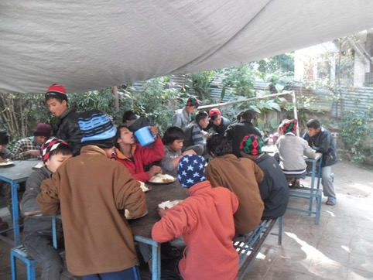
Street field workers inform street-based children about CPCS services, what CPCS can offer them. They encourage the child to walk toward its own social rehabilitation gradually, depending on his/her willingness.
CPCS short-term risk reduction programs conducted both in the streets and in our socialization shelters, which constitute the first steps to the building of a relationship between the street child and CPCS. CPCS then offers any street child who desires it, an individual counseling based on their personal history, educational background, personal abilities, age, and most important of all, on their personal wishes and interests.
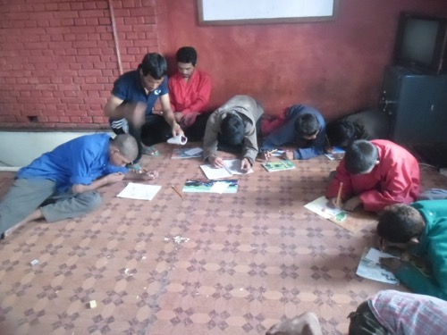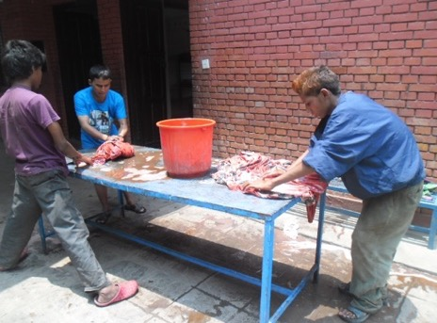
Through daily fieldwork and contact with street children within our centers, CPCS’ staff is well aware of the daily life and problems of street children. Yet, working within the changing environment of the street requires conducting regular evaluations of our programs and getting feedback about our services.
The quality of our social work relies on the ability of our teams to develop new strategies and to re-adapt old ones to enhance their impact. In addition, CPCS values very much its network with other NGOs working with street children around the world. In particular, being part of the Street Field Workers International
Network gives the opportunity to CPCS to share its experiences and learn from others.
CPCS’ outreach work is essentiallybased on daily day-and-night field visits and on activities within our open shelters. On the street, the children who meet with our social/field workers get information on CPCS’ activities and programs, counseling, informal education classes, and first aid. Our social workers are also responsible for identifying and approaching new street children.
In our socialization shelter, children who live and work in the street can come to get a meal, a bed and a shower, receive medical treatment, participate in cultural and sports activities and meet with our psychological counselor, educators, and lawyer. CPCS has developed these risk reduction interventions to offer quantitatively and qualitatively better services to children still living on the streets, in order to improve their daily living conditions. These children are often begging, picking plastics, or working in public vehicles.
Cases study from shelter children
Prakash Shahi (Name Changed) 12 years old from kathmandu In his family father works as mason, before long time he used alcohol to much now a day where he go hedont know before 4/5 months.His mother got second marriage before 2/3 years.
He has a younger sister only. Hehas a UncleAmon Shrestha he also staying on help Nepal before, He also stayed before came to cpcs. Around 4/5 years he stayed there now his uncle bring him here in CPCS. Now He is living in CPCS After he left the house, He went HELP NEPAL. Now I like to stay on cpcs. He has step father own mother younger sister.
Pascal magar(Name Changed) is 14 years old boy from okhandhunga. He has fathe rmother elder brother two younger brother and younger sister Inhis family, both paretns woprk as mason His elder brother also work labor with father. His younger brother read on Ukg on Samata school. He has two sister, they already got marriage.
Hehas a younger sister, She is reading on Lkg on Samata School Buddha. He was also studying on class 3 on Samata School But his father used alcohol then beats him and his elder brother also .
He was also left the house before , then went to street long time ,then he came to house and start to go to work with father, when he left the house after that he went to Buddha area then begging there then he went to volunteer foundation Nepal kalimati then he also went to Apc Nepal but from there he runaway then came to cpcs. Before 1 years he came to cpcs but he did not stay long time but now he wants to stay here on cpcs.

The street work

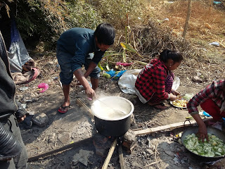
Day Field Visit
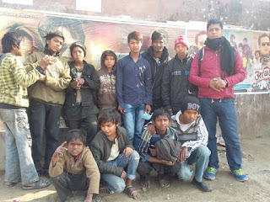
CPCS conducts daily field visits in the street. These outreach visits enable CPCS educators to get a better understanding of the street life, to identify new street children, keep, and build a relationship with them. During those field visits, a senior staff member, a social worker, and a nurse provide the children with medical first aid, counseling on the street, awareness sessions, informal classes and games. These day interventions are conducted in several areas of the capital daily.
The main areas of CPCS’ day field activities are:
Area 1 Baudhha, Pashupati, Tilganga Kalopul, Setopul, Gaushala, Chabahil, Gopikrishna
Area 2 Banepa, Bhaktapur, Koteshwor, Baneshwor
Area 3 Kirtipur, Balkhu, Kalanki, Kalimati, Swayambhu, Balanju, Gangabo, Bashundhara, Maharajgunj
Area 4 Gyawko, Mangalbazar, Lagankhel, Mahalaxmithan, Jawalakhel, Satdobato, Nakkhu
Area 5 Balaju
DAY OUTREACH PROGRAM IN KATHMANDU JAN-DEC 2015
Month | J | F | M | A | M | J | J | A | S | O | N | D
Area 1(Pashupati) - Average Nbr of Children | 29 | 24 | 34 | 27 | 28 | 30 | 28 | 22 | 15 | 29 | 35 | 45
Area 2(Mankal 2) - Average Nbr of Children | 12 | 11 | 15 | 23 | 25 | 24 | 20 | 18 | 16 | 22 | 20 | 15
Area 3(Kalanki) - Average Nbr of Children | 6 | 1 | 26 | 12 | 13 | 15 | 9 | 7 | 5 | 9 | 11 | 12
Area 4(Jawalakhel) - Average Nbr of Children | 23 | 24 | 32 | 25 | 25 | 15 | 9 | 7 | 5 | 5 | 7 | 11
Area 5(Balaju) - Average Nbr of Children | 4 | 1 | 26 | 10 | 10 | 14 | 8 | 6 | 5 | 5 | 8 | 5
Children met by Simple Field | 81 | 86 | 120 | 100 | 107 | 110 | 114 | 119 | 120 | 125 | 130 | 125
Children brought to center by Simple Field | 10 | 9 | 12 | 15 | 20 | 30 | 20 | 20 | 15 | 20 | 24 | 45

Night Field Visits
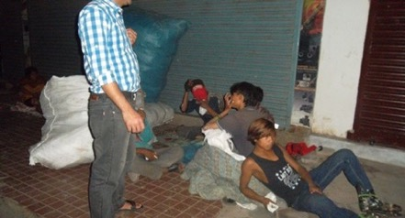
CPCS started night field visits 5 years ago. It operates daily from 7.30 pm to 11.00 pm except Saturday. A health assistant, a senior social worker and a driver for the ambulance go to the different areas of Kathmandu where street children hang out at night. Every night, the CPCS team meets an average of 17 children in different areas of the city.
The main objective of the night interventions is to reduce the children risk exposure, which is enhanced especially during the night. At night, children face more risks and are more vulnerable to any type of physical and sexual abuse. Children are frequently threatened or abused by the public or street elders. They are highly intoxicated by alcohol, marijuana or glue and can be physically injured during frequent gang fights. In some occasions that CPCS assesses as being “high risk” for the child, they may even decide to take the child to Bir Hospital, Teaching Hospital, Patan hospital, Kanti Hospital and then transfer to one of our CPCS centers.
The main areas of CPCS’ night field activities are:
Area 1 Pasupati, Chabahil, Tilganga, Bhatkyapool, Setopool, Gaushala, Old Baneshwor, Bhimsengola,
Area 2 Durbarmarg, Jamal, Shamakusi, Thamel, Kaldara, Lainchur, Newroad, Basantpur, Ratnapark, Bir hospital
Area 3 Kalanki, Soyambhu, Kalimati, Balkhu, Soltimod, Balaju, New Buspark, Ramghat, Dhungedhara
Area 4 Lagankhel, Jawlakhel, Pulchowk, Sanepa, Gwarkhu, Dhobidhara, Satdobato, Koteshwor, Mangal Bazar
NIGHT OUTREACH PROGRAM IN KATHMANDU JAN –DEC 2015
 | J | F | M | A | M | J | J | A | S | O | N | D
Area 1(DB) - Average Nbr of Children | 9 | 18 | 20 | 25 | 20 | 15 |  | 23 | 30 | 25 | 20 | 20
Area 2(DB 2) - Average Nbr of Children | 7 | 10 | 5 | 15 | 12 | 10 |  | 15 | 15 | 15 | 15 | 18
Area 3(Kalanki) - Average Nbr of Children | 3 | 3 | 3 | 5 | 3 | 9 |  | 10 | 10 | 8 | 10 | 10
Area 4(Patan) - Average Nbr of Children | 6 | 3 | 6 | 10 | 10 | 10 |  | 12 | 10 | 5 | 5 | 5
Nbr of Children treated on Field | 125 | 183 | 287 | 267 | 174 | 262 |  | 204 | 259 | 190 | 183 | 215
Children brought to center by Simple field | 1 | 1 | 0 | 0 | 0 | 1 |  | 0 | 0 | 2 | 0 | 11
Average Nbr children in daily Night field | 16 | 20 | 23 | 25 | 20 | 17 |  | 25 | 21 | 20 | 15
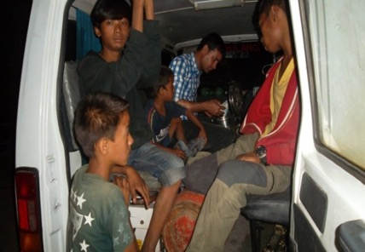

The Field Service is supported by Les amis de Soeur Emmanuelle and night Medical outreach work by the Nick Simons Foundation through the American Himalayan Foundation
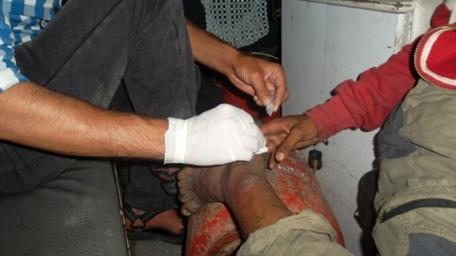

CPCS legal protection program
CPCS provides legal assistance to street children through its Legal Support Program (LSP). Two professional lawyers are ready to intervene when a child has been involved in illegal detention, recovering wage from master, in the case of sexual abuses, or when a street child wants to initiate the legal procedures to obtain his birth registration, citizenship certificates or parental inheritance. The legal support program also provides support to street children allegedly involved in criminal activities and those who are taken into custody. In these cases, lawyers provide them with support for court actions and release them from custody.
Most of the times children themselves call from the street to ask assistance to release their street friend from custody as weel they request legal support to recover wage from their work. Sometimes they asked ideas to make citizenship and support legal process.
A CPCS lawyer and an accompanying staff member conduct regular visits to police custodies. Many cases are also reported by the children themselves, by the police or by the public through our CPCS Emergency line. This shows that both the street children and the police consider CPCS as a professional and reliable organization. Daily, 2-3 calls are received from children directly from the street for various legal and medical support requests and queries for our lawyer.
RESULTS OF LEGAL SUPPORT JAN –DEC 2015
 | J | F | M | A | M | J | J | A | S | O | N | D
Jail visits | 4 | 4 | 5 | 6 | 4 | 4 | 5 | 6 | 4 | 4 | 2 | 3
Nbr of children/youths in jail | 4 | 4 | 5 | 5 | 4 | 4 | 3 | 4 | 2 | 4 | 2 | 2
Custody visits | 7 | 6 | 7 | 8 | 9 | 8 | 10 | 9 | 8 | 6 | 5 | 8
Nbr of children/youths met in custody | 6 | 6 | 11 | 8 | 6 | 5 | 7 | 5 | 0 | 4 | 0 | 3
Children/youths released from custody | 6 | 5 | 11 | 8 | 6 | 5 | 9 | 5 | 0 | 4 | 0 | 3
Court Action | 1 | 1 | 1 | 1 | * | * | * | 1 | 0 | 0 | 1 | 0
Meeting with Police | 1 | * | 1 | 1 | 1 | 1 | 3 | 5 | 2 | 0 | 1 | 0
Awareness /Class with Children | 185 | 200 | 240 | 260 | 260 | 232 |  | 260 | 155 | 152 | 110 | 170
Nbr of children who attended awareness Classes | * | * | * | * | * | * |  | 1 | 0 | 0 | 0 | 0
Awareness Program with Public |  |  |  |  |  |  |  | 6 | 4 | 4 | 2 | 3

Stories from the Legal Protection Program

Gokarna (name changed)has been living at CPCS from the very beginning. He served with CPCS as youth staff and was involved in the kitchen. He left his job because he found an opportunity in the youth alliance
He lives in Kalimati with street friends. The police arrested his friends and him, charging them of fighting in Thamel. Then,the police forwardedShyam’s case to the court.
While, he was in custody in Durbermarg, his friends came to visit him and he asked cigarettes from them. The police found the cigarettes and threatened to file a public nuisance case against him also. He called CPCS for help and we managed for him to he released from custody.

Samrat thapa (name changed)) He just came from Bethan VDC Ramechap before two days. He is 15yrs old . He staying with new friends at thamel.He was very innocent. Some friend sent to them for begging till two days. He can't earn money because he was new. Some friend tries to sexual abuse to them. After one week shyam sent to for stolen to bicycle.Shorakhutte police recently arrested him.
He is very crying at night.Police called to CPCS emergency line 9:00PM. CPCS staff went to police station and talked with police. Police also know he is innocent.So he release from custody. Then after CPCS night field in charge to him for rehab. Now he has reunification to family. if we have not reached to in time police sent to jail. He is new in the street. He has mother and father.

The emergency line – 44 11 000
CPCS operates a twenty-four hours emergency line; 44 11 000. The number is open for the citizens, parents, the police, shopkeepers, tourists, teachers, GOs, other NGOs, and most importantly, to street children themselves. Street children mostly call us to inform us about a fight, an injured child or a friend that has been taken into custody, whereas other groups of people call us to report a case, or to get information about children at CPCS and our services. During 2015,the CPCS Emergency line received 500 calls.
24 HOURS CPCS EMERGENCY LINE JAN – DEC 2015
 | J | F | M | A | M | J | J | A | S | O | N | D
Medical Problems | 10 | 15 | 15 | 11 | 12 | 11 | 4 | 4 | 5 | 1 | 0 | 0
Under arrest | 8 | 7 | 2 | 8 | 9 | 8 | 3 | 3 | 1 |  | 0 | 0
Abuses - trafficking | 0 | 0 | 0 | 0 | 0 | 0 | 0 | 0 | 0 |  | 0 | 0
Others | 11 | 13 | 6 | 11 | 4 | 7 | 10 | 10 | 2 | 1 | 0 | 0
Child Labor | 0 | 0 | 0 | 0 | 0 | 0 | 0 | 0 | 0 |  | 0 | 0
Information | 27 | 21 | 22 | 26 | 18 | 16 | 28 | 28 | 39 | 34 | 3 | 20
Kathmandu - Line | 58 | 58 | 47 | 56 | 43 | 42 | 45 | 45 | 47 | 36 | 3 | 20
Child Lost Cases | 0 | 0 | 0 | 0 | 0 | 0 | 0 | 0 | 0 | 0 | 0 | 0
Family Missing Cases | 0 | 0 | 0 | 0 | 0 | 0 | 0 | 0 | 0 | 0 | 0 | 0

In addition, the government-run National Centre for Children at Risk (Balbalika KhojTalas Kendra) referred 85 children to us by calling our emergency line. Among those 85, a child has an unknown family status. CPCS and Khojtalash reunified 26 children with their families.

Stories from the Emergency Line
Raju Adhikari(name changed) called the Emergency line to inform that the police had arrested him. He claimed thathe was arrested without reason. CPCS staff went to Durbarmarg police station to talk about his case. The police told themthat he was involved in pickpocketing from a passer-by.The police was planning to file his case in court. CPCS is working on this case now.
Aanis Shrestha(name changed) calledthe emergency line at 12.55 p.m to report about his friend arrested by the police. The police station in Durbarmarg called CPCS and explained that the followingyouths: he, Krishna Shrestha and Bijesh Tamangattacked eachother with a knife and injured eachother. A CPCS lawyer went there and suggested that the youths should not to stay in streets. He released them from custody and told them to go CPCS for treatment but they refused. hestayed with CPCS for 2 months in 2010. Now they are back in the street.
The Emergency line is supported by the Nick Simons Foundation through the American Himalayan Foundation

The CPCS Socialization Shelter
CPCS opened a socialization shelter in Sifal in December 2012, in the same building as our clinic. While this program was previously run in Dillibazar, CPCS decided to move it to Sifal, which is situated in the Pashupati area, because of the street children’s population density in that area and the absence of other NGO shelters for street children.
Far from substituting our fieldwork, the socialization shelter is a place where street children know they can be safe at night and receive assistance when needed. It is also a place that they can come to for entertainment such as football games, board games, or watching a movie while the educators take this opportunity to raise awareness on AIDS/HIV, drugs, child rights and give information about what CPCS can offer them if they decide to leave the street. Frequent and informal meetings with our staff through games, sports and other activities enable our social workers to build a relationship with the street child.
Since Janauray 2015, the Recovery Center moved to Dillibazar, followed by the whole socialization program. The program is conducted in a building with nine rooms, which can be occupied by more children. CPCS celebrates traditional festivals regularly in all the shelters with music, delicacies, meals, picnics and cultural activities.
The aims of the socialization shelter are the following:
- To offer the children a safe place to sleep, take care of their personal hygiene and socialize with other children.
- To give the children nutritious and hygienic meals.
- To offer the children free access to medical care and counseling in our clinic.
- To provide children the opportunity to access the « street banking system ».
- To offer the children non-formal education, sports, culture and child rights classes.
- To manage family reunifications and family visits.
- To provide children legal assistance and plead on behalf of them in case of court action.

Self-management
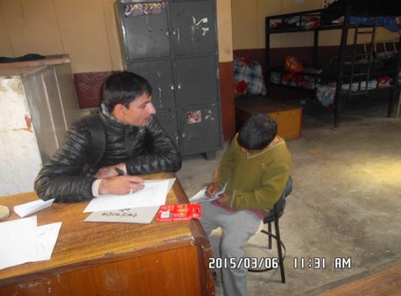
The socialization shelter in Sifal is partly managed by the children themselves. Our approach consists in giving the children a sense of responsibility by giving them the chance to play an active role in the structure and organization of the shelter. They are responsible for its maintenance, the shopping for food, the cooking, and for defining the rules of good behavior. The team involved in the management of the shelter triesto make the children understand that they are there by choice and that although they have rights they also have responsibilities. For example, the children have to do househoold chores and cleaning.

Daily activities and classes
We offer several activities to the children spending their day in the shelter such as football, games, ping-pong competitions, educational games and cultural activities (drama and music classes). In addition, social workers teach the children their alphabetization and increase their knowledge about health and hygiene. These activities and classes are not compulsory. However, if a child does not take part in the activities suggested by our social workers, they get rice, lentils, and no vegetable curry, while the ones who do attend these classes get a full meal with vegetable curry. This is our way to encourage children to participate in the activities and to put the child face to face with their responsibilities. This system encourages children who cannot find a job to come to class rather than to stay on the street.

The Educational Ticket (ET) System
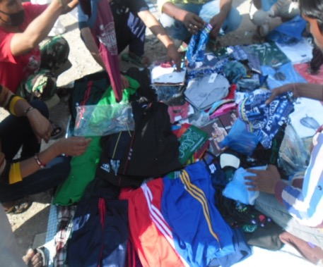
When all the children are back from work, and have had their dinner, we organize three informal education classes. For every class session attended (mathematics, English, Nepali, child rights, etc.) the child receives an “education ticket” that can be used to purchase goods for their everyday life from CPCS “store”. This store provides them with soap, toothbrushes, sandals, football shoes, combs, gels, shampoo, and clothes among other things. They are then able to keep their personal belongings in separate lockers. The aim of this system is to make the children value their belongings, and teach them how to be responsible. We believe that this will make the children well prepared for life in society and appreciate things better. At the same time, this system shows that working on the street is not obligatory. In fact, while participating in classes and activities, in our buildings and in safety, not only do the children acquire essential tools for their future life, but in addition, they receive educational tickets to purchase what they need.

The street banking system
Our “street banking system” teaches children to save money and protects street children from having their money stolen by street gangs or junkyard owners to whom they are in debt.
Children can deposit their money with us and get it back whenever they like. This program was created at the request of the children. The banking structure allows the street children to change their smoking or drug habits, to discover the advantages of saving and to adopt a more responsible lifestyle. The street bank is also a tool to socialize children.

Individual lockers
Locker deposit boxes are provided to the children who sleep in the shelter. Each child has its own key. This system allows the children to sleep safely without having to worry about their small belongings (clothes, shoes and valuables) while they are staying at the shelter.

The Picnic Program
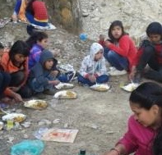
According to 28 street based children and 4 staffs /youth had godhawari picnic from CPCS shelter program, It was great with kids , they feel very happy to stay one night also . after long time they enjoyed with picnic before we couldn't send in their of situation of blog of india, but we did that picnic program with kids. Now there is so cold 7 to 17 Dc weather, they fire wood and took worm. CPCS has opened a picnic spot in Godawari, which is located outside of the city. Since 2009, the children are regularly taken to picnics in groups of about 20-25 children. This offers them the opportunity to socialize with one another and tightens the bonds both with the other children and with our social workers. Generally, the Godawari picnic is a 2 days program with one night halt in the center.
In addition to these weekly picnics, CPCS organizes a gathering of all street children once a year. During this event, all the children go to the picnic together and spend the day there eating and playing. This allows the children living on the street to interact with children from our socialization centers. On January 20 2015, the16children from the rehabilitation Dillibazar particiapted in the Godawari picnic.Similarly, on June 28 2015, 28 children from Sifal Center went to the Godwari picnic.

The smoking zone
The smoking rate among street children is high. Therefore, CPCS runs a tobacco consumption reduction program. The children are allowed to smoke cigarettes within CPCS premises at given spots and only at certain times of the day. It is in Sifal center only even though we hang NO SMOKING board in every Center

The library
The shelter library contains books on different subjects (science, fiction, cartoons, poems, etc.) and is used by several children each day. They can borrow the books as they wish. Most of the time, they read and enjoy different books and comics. It is fixed in reception in bog cupboard where children can access and choose for read.
RESULTS OF SIFAL SOCIALIZATION CENTER FOR JAN-DEC 2015
Daily Average Use | J | F | M | A | M | J | J | A | S | O | N | D
Morning Class | 12 | 8 | 12 | 12 | 6 | 10 | 12 | 9 | 8 | 14 | 13 | 16
Morning Exercise | 16 | 14 | 13 | 13 | 13 | 13 | 23 | 18 | 12 | 15 | 20 | 19
Afternoon Class(Activities) | 10 | 11 | 13 | 13 | 14 | 13 | 16 | 14 | 11 | 15 | 16 | 14
Evening Class | 6 | 9 | 9 | 12 | 2 | 7 | 7 | 7 | 8 | 9 | 8 | 8
Morning Meal | 11 | 8 | 11 | 11 | 15 | 10 | 13 | 11 | 9 | 15 | 15 | 15
Snacks | 10 | 11 | 13 | 13 | 13 | 12 | 16 | 14 | 11 | 15 | 16 | 14
Evening Meal | 11 | 11 | 11 | 11 | 11 | 8 | 9 | 8 | 8 | 11 | 11 | 9
Night Shelter | 17 | 15 | 16 | 16 | 11 | 12 | 20 | 19 | 13 | 15 | 18 | 18
Total Registration | 1 | 2 | 1 | 4 | 3 | 3 | 9 | 1 | 5 | 1 | 0 | 1
Total Referral | 1 | 1 | 4 | 2 | 3 | 3 | 10 | 2 | 7 | 4 | 7 | 5

Stories from Sifal shelter
Ram thapa(Name changed)is a 14 years old from Nawalparasi district. His mother was dead due to gas cylinder brust when he was very young . He hasa elder also. And then his father married second wife. My father is a tractor driver.
He is interested to study further and He used to go to school. He has studied up to class 3 in Nepal Rastriya School, Nawalparasi. District, one day when he was coming back from school, my step mother forcefully sent him to Kathmandu with his friends to earn money.
After that he worked in Hotel in Balaju for 2 months he used to wash dishes and clean the rooms. He also used to cook foods for hotel. He did not like to work in hotel so He run away from there and came to pashupati. From pashupati, his friend brought him to CPCS, sifal. He wants to study further and be a good man in future.
Her name is RitaThapa ((Name changed) 16 yrs old, now she is staying with family in tilganga near pashupati kathmandu. Her father is rag piker and mother is also work in junkyard. Her two sisters are married. She had burn case in pashupati, sometimes her mother and father fighting with each other so she came to street. Sometime she had slept in Bhandaarkhal , and sometime go to her room with family. She didn’t like to be with her family they always fighting with each other, there are 8 members of family it’s too big and not in of money for eat. she was in street from her childhood but she was not sleep in street, but now some time she sleep in street with my friends. She is not afraid in the street it’s her habits to stay in street. 6 months ago she was married with one boy he was not from street. His family always bites to her so she left him and his family. Now she is with her family. She spend her time always in street with street boys and girls; 2 times she has got chance to stay in cpcs girl hostel godhawari, she was fight with her friends in there then after cpcs’s miss reunified her with family.She has a few of interest play badminton. She had 6 classes, in maiti Nepal, teresha academy from Prayas NGO. Teacher was misbehaver to her so she stop to go to school. She had take beauty parlor training 1 month half. It’s not too long so short and it’s hard also. Some time shesmoke and take ganja, glue sniffing, also not regular if she get tense
She don’t have any plane to do on my future but sometime she like to work in house for cleaning washing clothes. she is thinking that she is not staying long time in the street, one day she leave but when?? She has mother step father and elder ssiter
The Socialisation Shelter program is supported by Les amis de Soeur Emmanuelle – Belgium and the Vieujant Foundation

Medical Support Program
In order to support street children’s medical rights, CPCS has implemented a Medical Support Program. This program consists of
- Conducting day-and-night field visits and provide first-aid treatment to street children directly on the streets.
- Providing first-aid or medical support for minor injuries & illness to children of all CPCS programs and centers.
- Referring more serious cases such as surgery, diagnosis, lab tests or further medical intervention to public hospitals.
- Increasing the street children and youths’ awareness about the risk of HIV, AIDS, drugs, Hepatitis, Jaundice, STI’s, STD’s and other communicable diseases.

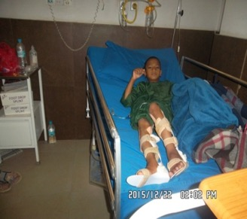
The CPCS medical staffs are present in different zones in Kathmandu. They either give first-aid on the field or accompany the patient to a CPCS clinic. Most of the time, it is the street children themselves who come to CPCS or call the emergency line4411000 when they are in need of medical assistance. Our ambulance can pick up the children in need of urgent medical assistance directly from the street and can then bring them either to the Dillibazar Recovery Center or to the hospital (depending on the situation). In fact, our organization works in partnership with several public hospitals that we refer children to when in need of further medical intervention, surgery or medical examination and analysis (X-Ray, lab, CT scan, MRI).
Furthermore, our Recovery Center based in the Dillibazar Center allows children from our centers or from the street who need further treatment or rest (e.g., after undergoing surgery) to stay in a secure and clean place with medical assistance.
Medical support is provided to all children without any discrimination, regardless of their pathology, their toxic addiction, or their HIV status.
Besides pure medical intervention, the Medical Support Program also aims at raising general awareness among street children (AIDS/HIV, Hepatitis, etc.) and organizing health camps with the objective of conducting medical check-ups.
The CPCS medical team meets with other health organizations in Nepal on a regular basis. For example, we frequently participate in an Ambulances Management meeting in the District Health Office, Kathmandu to ensure that we follow the rules and regulations applicable to ambulances in general. CPCS also participates in coordination meetings with the Nepal Red Cross Society, the Chief District Officer, and the Nepal Police about mechanisms and strategies to be adopted by social NGOs to rescue street children when demonstrations and general strikes hit the country.Our medical staff face some serious infection risks (AIDS, hepatitis or other diseases) due to their work. Therefore, through preventive measures such as trainings and immunization, CPCS ensures the staffs remain healthy and safe.

Our Recovery Centre
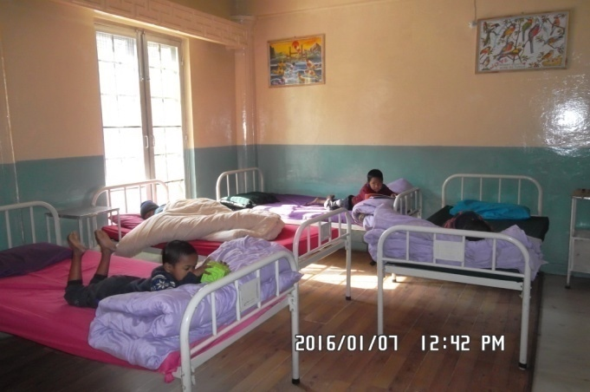
The Recovery Center is open 24 hours a day. It is situated in Dillibazar Pipalbot. Professional health assistants and qualified nurses are constantly taking shifts to offer 24 hours of healthcare. There are 10 beds in the clinic where the sick children can watch television or read a book from our library. Special meals are prepared according to doctors’ recommendations. The clinic treats many viral diseases and epidemics, (flu, hepatitis, etc.). End of December 2014, the Recovery Center moved to Dillibazar first floor where there is big space and nice ventilation.

MEDICAL SUPPORT KATHMANDU JAN– DEC 2015
Type of Service | J | F | M | A | M | J | J | A | S | O | N | D
Number of children treated (clinic out patients) | 313 | 188 | 247 | 203 | 210 | 199 | 242 | 278 | 187 | 152 | 267 | 321
Average per day | 11 | 13 | 8 | 8 | 8 | 7 | 9 | 10 | 6 | 5 | 10 | 11
Number of in-patients in clinic | 155 | 120 | 170 | 124 | 92 | 161 | 228 | 199 | 229 | 288 | 255 | 206
Average per day | 6 | 8 | 6 | 6 | 3 | 6 | 8 | 7 | 8 | 9 | 9 | 7
In-Patients bed Nights | 191 | 110 | 89 | 94 | 91 | 185 | 239 | 246 | 260 | 343 | 300 | 196
Average age of in-patients | 11 | 17 | 11 | 10 | 16 | 15 | 12 | 11 | 12 | 10 | 15 | 16
Number of hospital cases | 4 | 2 | 2 | 4 | 0 | 12 | 21 | 21 | 27 | 19 | 15 | 10
Number of patients admitted in hospital | 0 | 0 | 1 | 0 | 1 | 2 | 1 | 2 | 2 | 2 | 1 | 1
Total Number of Hospitalization Days | 0 | 0 | 2 | 0 | 31 | 42 | 31 | 38 | 38 | 29 | 5 | 3
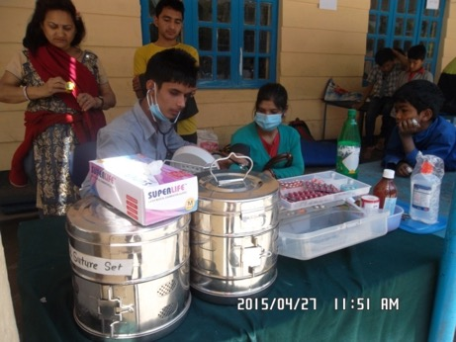
SIFAL Recovery Corner JAN-DEC 2015
Type of Service | J | F | M | A | M | J | J | A | S | O | N | D
Number of children treated (clinic out patients) | 134 | 192 | 273 | 393 | 380 | 331 | 419 | 351 | 320 | 338 | 258 | 296
Average per day | 5 | 7 | 9 | 13 | 12 | 11 | 13 | 11 | 11 | 11 | 5 | 9
Number of hospital cases | 13 | 14 | 15 | 15 | 16 | 15 | 2 | 0 | 0 | 0 | 0 | 0
Total Number of referral case to Sifal Clinic | 0 | 0 | 0 | 1 | 0 | 0 | 2 | 2 | 7 | 2 | 6 | 3

Girl’sRecovery Center JAN-DEC 2015
Type of Service | J | F | M | A | M | J | J | A | S | O | N | D
Number of children treated frequently in girls home | 125 | 167 | 110 | 101 | 94 | 107 | 103 | 101 | 79 | 92 | 121 | 89
Average per day | 5 | 6 | 4 | 4 | 3 | 4 | 3 | 3 | 3 | 3 | 4 | 3
Number of hospital cases | 6 | 6 | 0 | 0 | 0 | 0 | 0 | 0 | 0 | 0 | 2 | 3
Average per day | 1 | 1 | 0 | 0 | 0 | 0 | 0 | 0 | 0 | 0 | 0 | 0

Dolakha Recovery Center JULY-DEC 2015
month |  | J | A | S | O | N | D
1 | Number of children treated (clinic out patients) | 1 | 11 | 10 | 21 | 11 | 10
2 | Average per day | 1 | 5 | 3 | 3 | 7 | 4
3 | Number of in patients (admitted in clinic) | 0 | 0 | 0 | 0 | 0 | 0
4 | Average per day | 2 | 2 | 5 | 4 | 4 | 9
5 | In Patients bed Nights | 0 |  | 1
6 | Average age of inpatients | 7 | 9 | 9 | 8 | 10 | 9
7 | Number of Hospital Outpatients | 0 | 1 | 11 | 2 | 11 | 14

During the first six months of 2015, the medical outreach programs covered Jhapa to Dhangarhi. There were many cases of fever, cough, diarrhea, allergy, cuts, wounds, eye problems, gastritis etc. Three to sixteen years was the average age of the patients. Parents were also checked up during the visit. During the visit, the team provided medicine, health education, first aid and counselling to the parents and children.

CPCS outreach medical program during (January-December 2015)
Session subject | Location | Nbr | Program | Month
visit/health check up | Kalanki | 6 | Medical check up and awerness class | FEB
visit/health check up | Mulpani | 17 | Medical check up and providing related diseases medicine | FEB
visit/health check up | Sanothami | 11 | Medical support/taking health class  medical check up | MAR
Health check up /class visit | Jhapa | 88 | 1. family councilling  2.health check up and deworming of children  3. meeting with children and parents  4. awerness about swine flu for participatents(children and parents) | MAR
Health check up /class visit | Ithari | 88 | Health check up, awareness about swine flu, meeting with children and parents, deworming, personal hygiene class. | MAR
Health check up /class visit | Birtamod | 90 | health check up, awareness about swine flu, meeting with children and parents,deworming, personal hygiene class, medicine distribution | MAR
Health check up /class visit | Dhangadi | 56 | 1. family counselling  2. health check up  3. First aid knowledge for children,parents and LSA  4. First aid medicine distribution  5.meeting with children, and parents about his/her studies, general health and other topics, | APR
Health check up /class visit | Surket | 88 | 1. Health check up  2. family counselling about personal hygiene  3.First aid knowledge for children,parents and LSA  4.Meeting with childrenand parents about his/her studies,health  5. First aid medicine distribution | APR
Health check up /class visit | Butwal | 49 | 1. Health check up  2. family counselling about personal hygiene  3. First aid knowledge for children, parents and LSA  4. Meeting with children and parents about his/her studies, health  5. First aid medicine distribution | APR
Health check up of earthquake victim/child and their family | Halchok | 70 | Providing a tent mattress/food /blanket/health checkup of children and their family and public | MAY
Health check up of earthquake victim/child and their family | Bhaktpur | 60 | Providing a tent/mattress/blanket/  health check up of children and their family and public | MAY
Health check up of earthquake victim/child and their family | Chobar | 100 | Providing a tent/mattress/blanket/  health check up of children and their family and public | MAY
Health check up of earthquake victim/child and their family | Dolakha | 150 | Playing games /health check up of child and their family and public | MAY
Health check up of earthquake victim/child and their family | Chorikot | 250 | playing game/health check up/providing food | MAY
Health check up of earthquake victim/child and their family | Budhanalkantha | 50 | health check up of children and their family and distribution of relief materials | JUNE
Health check up of earthquake victim/child and their family | Mulpani | 40 | health check up of children and their family and distribution of relief materials | JUNE
Health check up of earthquake victim/child and their family | Kalanki | 60 | health check up of children and their family and distribution of relief materials | JUNE
Health check up of earthquake victim/child and their family | Halchok | 40 | health check up of children and their family and distribution of relief materials | JUNE
Health check up of earthquake victim/child and their family | Balaju | 50 | health check up of children and their family and distribution of relief materials | JUNE
Health check up of earthquake victim/child and their family | Bhaktpur | 60 | health check up of children and their family and distribution of relief materials | JUNE
Health check up of earthquake victim/child and their family | Gorkha | 60 | health check up of children and their family and distribution of relief materials | JUNE
Health check up of earthquake victim/child and their family | Halchock | 21 | health check up of children and their family and distribution of relief materials | JULY
Health check up of earthquake victim/child and their family | Balaju | 27 | health check up of children and their family and distribution of relief materials | JULY
Health check up of earthquake victim/child and their family | Bhaktpur  Sanothimi | 30 | health check up of children and their family and distribution of relief materials | AUG
Health check up of earthquake victim/child and their family | Chalnakhel and kirtipur | 60 | health check up of children and their family and distribution of relief materials | AUG
Health check up of earthquake victim/child and their family | Bhaktapur | 50 | health check up of children and their family and distribution of relief materials | AUG
Health check up of earthquake victim/child and their family | Syuchatar and Halchowk | 75 | health check up of children and their family and distribution of relief materials | AUG
Health check up of earthquake victim/child and their family | Chautara | 30 | health check up of children and their family and distribution of relief materials | SEPT
Health check up of earthquake victim/child and their family | Dolakha  Different Places | 250 | health check up of children and their family and distribution of relief materials | SEPT
Health check up of earthquake victim/child and their family | Banepa | 30 | health check up of children and their family and distribution of relief materials | SEPT
Health check up of earthquake victim/child and their family | Gorkha | 30 | health check up of children and their family and distribution of relief materials | OCT
Health check up of earthquake victim/child and their family | Ramechhap | 60 | health check up of children and their family and distribution of relief materials | NOV
Health check up of earthquake victim/child and their family | Sindhuli | 50 | health check up of children and their family and distribution of relief materials | NOV
Health check up of earthquake victim/child and their family | Balaju | 25 | health check up of children and their family and distribution of relief materials | DEC
Health check up of earthquake victim/child and their family | Budhanilkantha | 25 | health check up of children and their family and distribution of relief materials | DEC

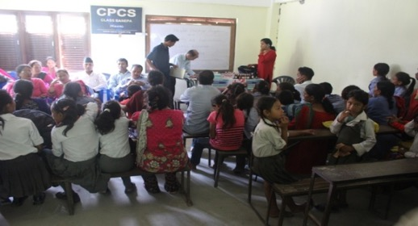

Stories from the CPCS Recovery Center

Kal Rai(Name Changed)is 24years old. He comes from India and is living in Sundhara. He looks like anIndian Bengali but he told everyone he is Nepali. His mother passed away and his father was a drunkard. He left home 17 years ago. He doesnot know about his native land. He was taken in by a Nepali couple who changed his surname. He was in CPCS in 2004. He works in a junkyard. He had head injury problem when he fought with a friend andwas admitted in the clinic for a few days.
Raman ((Name Changed) is 15 yrs old from Sindhupalchowk now living in pashupati area His Grand Father was from Sinduplanchwok due to earthquake of 1990 BS, he came in Kathmandu he had started to work in Airport and then he met with a girl of Trisuli and got marriage with her. Father of Shiva was born in Airport. Then, he had come in the street and stayed at Pashupati area and stay at Paty of Pashupati area. In Pashupati, His uncle was born and slowly both his grandfather and mother passed away and his father and uncle got marriage and he born and uncle has one son.
Then his father death in Pashupati and mother got marriage with others and now heard she was in Pokhara and she is mentally retired. While Pashupati Development Board chase them from Pashupati area his uncle take room and support him and his son both but he left room and fall in bad behavior/fellow but his son study in grade 10 now. He also worked in Pashuapti temple for cremation. He fall from tree in surya ghat pashupati areahis uncle took him foir treatment in KMC hospital .He discharges from KMC and came to CPCSshelter Sifal He got sick and referred to Dillibazar for treatment. He had chest pain cant speak left limbs lower parts seisure and mental problem. He sent to Bir Hospital KMC, Tranquility Hospital Mental Hospital and referred to Neuro Hospital for further treatment.This time he fall from Surya Ghat and he was serious. Then his uncle received him and took to the hospital and treat him. He spent around 60000 through loan and cared him.
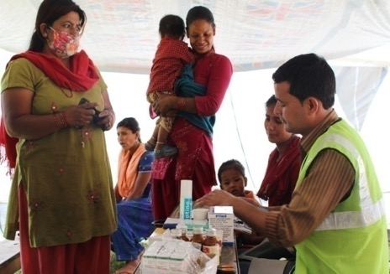
When discharged with relief and brought in room again he went out and goes to street so now he cannot do anything. If you bring here he has no other option just only way to kill him and make me free. He was sick and cannot speak properly and just bump and hit his head in wall and crying. Then he took hosptial healing center they deny to admit then try other governemtnal hosptial they also deny to admit him then he took to neuro hosptial and admitted for 2 months he recovered and now he is ok he want sto go back apshupati then he went back to pashupati his health is now ok. He wants to become a police officer in future

The Recovery Center and Medical Programs are supported by the Nick Simons Foundation through the American Himalayan Foundation

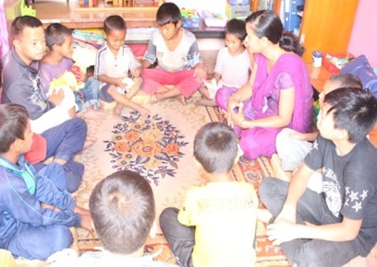
Counseling Services
Most of the children met by CPCS or living in CPCS centers have experienced street life and its dangers. A majority of them have been victims of physical, psychological or sexual abuses and have experienced drug addiction, criminal activities, or detention. These experiences often result in psychological disorders such as low self-esteem, loneliness, insecurity, inferiority complex, substance addiction or violent behavior. Therefore, CPCS provides psychosocial support to street children and former street children, through peer-to-peer sessions or group sessions.
CPCS has two psychological counselors providing counseling to children from all programs and centers. Our counseling program is based on a referral system where social workers refer children in need to the psychosocial support cell. Children can also request themselves to meet with one of the psychosocial counselors. In turn, counselors are working in close collaboration with the rest of the staff to ensure a proper and effective follow-up of each individual. In fact, the psychosocial counselors are key actors of children’s rehabilitation and their observations are taken into consideration when looking for a solution suited for each child (family re-unification, our schooling program, etc.). The counseling room is located in the Dilibazar center with professional counselors who provide alternate hours from morning to evening.
COUNSELING SERVICE IN KATHMANDU JAN –DEC 2015
 | J | F | M | A | M | J | J | A | S | O | N | D
Individual Counseling | 84 | 70 | 74 | 79 | 89 | 103 | 93 | 89 | 102 | 103 | 90 | 101
Group Counseling | 24 | 20 | 27 | 22 | 26 | 25 | 16 | 19 | 16 | 20 | 22 | 24
General Awareness Classes | 22 | 31 | 28 | 34 | 150 | 28 | 20 | 21 | 16 | 14 | 16 | 22
Sexual Abuses Victims Supported | 1 | 1 | 1 | 0 | 1 | 1 | 1 | 0 | 0 | 0 | 0 | 0
Physical and moral abuse victims supported | 5 | 4 | 3 | 3 | 3 | 4 | 4 | 5 | 4 | 3 | 4 | 4
Awareness Sessions with the team | 2 | 2 | 2 | 2 | 2 | 2 | 2 | 2 | 2 | 2 | 2 | 2

Stories from CPCS Counseling Services
Sapana dhami (Name Changed) is from Sindhupalchowk,and is 15 years old. She is living in Mulpani.Both of her parents are laborers. She studies in class 8 and her parents are too busy to look after her. She was abducted and taken to Tokha where she was held hostage for 32 days. Since the area that she was taken to was very remote, Sapana did not know the place well. She was only fed once a day at evenings, and the food was given along with drugs. One evening she managed to escape from the kidnappers and lived with a villager she had just met, for one day. Then she went back to her home. She reported her case to the police and they managed to catch the kidnappers. The kidnapping leader was sentenced to 14 years in jail. Her parents stopped sending her to school after the incident and after the villagers started mocking her. After the earthquake her room totally collapsed. Then she started to live in tents along with her landlords.
One day an old woman requested Sapana to take her to a place named Kadhaghari. This woman was linked to the previous kidnappers so she managed to kidnap Sapana again. Sapana was taken to a remote place in a vehicle when the vehicle stopped for a rest. Sapana took advantage of the situation and ran away. She was found by the police, and they brought her to CPCS. She is emotionally disturbed and doesn’t want to go back to her home. She wants to stay in CPCS and continue her studies. However, She is ready to go for a family visit under the supervision of our team.
Rajan Thapa(Name Changed)is 7years old, originally from Sindhupalchowk . He is living in baudhha After his mother remarried, he came to Kathmandu with his father and started living in Boudha. Then his father also remarried. His father was a laborer and his step mother begged in the Boudha area. Their economic condition was very poor and both of the parents were alcoholic. They used to beat him. Sometimes he begged and collected garbage with his step mother who tortured him physically and emotionally.
One day his step mother left him in front of our Shiphal center. Then he came to Dillibazar and started living at Rehab program. In the beginning he seemed very lonely and lacked focus on everything. Gradually he started participating in different activities. He started getting better. After 2/3 counseling session he seems happy and interested to join schooling program.
Satpal (Name Changed) his father remarried and went abroad for work. He is 15years old. He is from Trisuli His mother also remarried and after that he started living at his relative’s home. He studied up to class 3 and couldn’t study further. He has to do all house hold chores and his uncle constantly abuses him physically and emotionally. Durge's parents never supported him .He couldn’t bear any it more. So, he ran away from his home and started living in the street and started smoking cigarettes. Then he made friends and he came to CPCS with his friends. After two counseling session he seems very serious and confused. He needs more counseling session.

The Counselling Services are supported by the Nick Simons Foundation through the American Himalayan Foundation
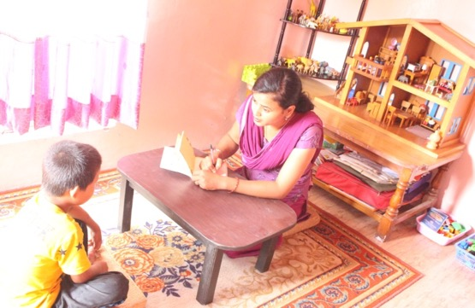
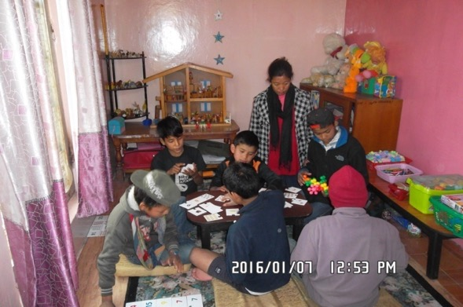

3 - Social Rehabilitation Centers and Services
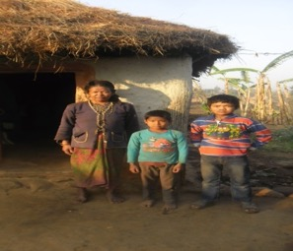
CPCS has developed services to encourage street children’s’ social rehabilitation as well as protect children from risk through various programs. The first objective is the child’s reintegration into its community and with its family whenever the conditions allow it. The public often believes that street children have no family. Yet, this is generally not the case.
Through its Social Rehabilitation Centers and Services, CPCS offers services suited to every street child’s story, age, personal wishes, and family situation. We aim at encouraging them to leave the streets and then tempt them toward social rehabilitation, whether it is with their family or within one of our centers. However, we insist on the fact that the rehabilitation of street children should be done with motivation and willingness.
Once a child decides to leave the street, he can join our Rehab program in the Dillibazar socialization center. Through individual counseling sessions, informal classes and daily interactions with our staff during the time spent in Rehab, we try to evaluate what would be the best solution for the child. Children are then either oriented towards non-formal education, formal education or vocational training.

The Identification Process
The identification process is part of our Risk Reduction Programs. Street children are identified by social workers who try collecting as much information as possible about each street child with the objective of getting a deep understanding of the child’s personal background, history and family situation. What often happens is that children (who generally come from rural areas of Nepal) do not know their exact address or family name. Therefore, CPCS has developed different strategies for the identification of the child and its family. This includes asking the child itself and interviewing the child’s surrounding environment (friends, etc.), publishing announcements in newspapers when a child is not able to give sufficient information to identify his/her family, and conducting field visits in the area mentioned by the child to inquire with the local people and local authorities.

The Family Reunification Process
CPCS strongly believes that the best place for a child to develop itself is within its family, as long as and if the situation allows it. In addition, street children often express their will to go back to their houses during counseling sessions and interaction with the social worker. Family reunification success relies on the child’s willingness to return home and on the family’s readiness to receive their child again. CPCS never pressures a child to go back to its family or on a family to take back a child. The outlook of this is that CPCS has developed a set of mid-and- long-term interventions with the families concerned, for each stage of the family reunification process. Our family reunification social workers cell support these “before”, “during” and “after” stages. CPCS interacts with the child, the social worker and the family to analyze the reasons for why the child ended up on the street in the first place: poverty, family problems or other reasons. We organize child counseling and family visits. After family visits, CPCS evaluates the possibility of reunifying the child with its family.
CPCS plays a mediator role, which motivates children to go back home to their family and reintegrate with society independently. Reunified children remain in contact with CPCS, making it possible to monitor the situation. This way we can see if the child stays with the family or ends up back on the street. During festivals or other cultural events, CPCS lets children visit their family, which is another tool to reunite children with their families voluntarily.

Glimpses of year 2015 in CPCS centers

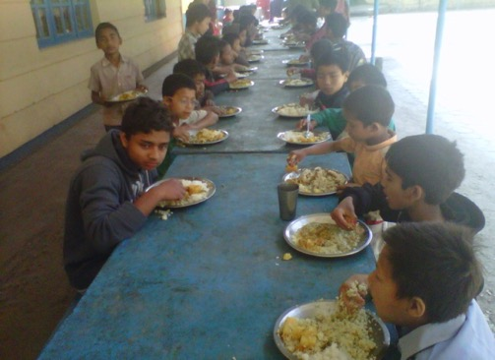
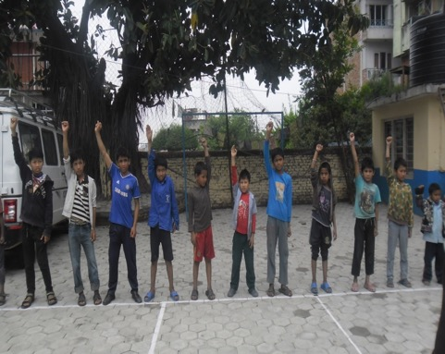

The Rehabilitation center for boys in Dillibazar
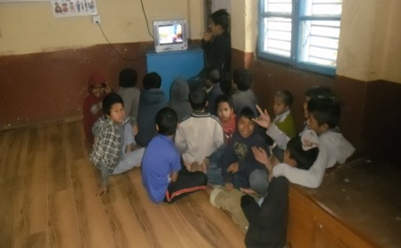
The CPCS rehabilitation program is for former street and working children who want to leave the street life in order to develop themselves within a more positive and promising environment. Children are offered three educational sessions per day; Nepali, English, mathematics, physical education, or personal hygiene. This program mixes education and socialization through arts and sports and helps bring back children’s self-esteem. It enables children to get over bad street habits such as drug addiction, violence, and pick-pocketing, and preparing them for a more rigorous study program or family reunification.

Due to the fact, children involved in these programs have spent time on the street enjoying total freedom and living in a world without any form of obligations and commitments, their stability often remains fragile and temptations to go back to the streets are frequent. CPCS therefore particularly focuses on personal counseling with help from our social workers and regular interventions with the psychological counselors. After having spent two months in Rehab, children who have not been reunified with their families join the Rehab 2 program where more long-term solutions are considered such as referral to other NGOs for vocational training, or schooling programs.
CPCS Rehabilitation Center Dillibazar JAN-DEC 2015
 | J | F | M | A | M | J | J | A | S | O | N | D
Nbr of children (beg) | 19 | 18 | 22 | 22 | 1 | 9 | 14 | 12 | 8 | 8 | 10 | 7
New children | 1 | 9 | 5 | 2 | 12 | 9 | 10 | 0 | 4 | 8 | 4 | 4
F.R from office | 2 | 4 | 0 | 1 | 4 | 3 | 6 | 0 | 4 | 4 | 3 | 0
F.R through partners | 0 | 0 | 3 | 0 | 0 | 0 | 0 | 0 | 0 | 0 | 0 | 0
F.R after H.V | 0 | 1 | 2 | 1 | 0 | 0 | 0 | 0 | 0 | 0 | 0 | 0
Internal Referral | 0 | 0 | 0 | 19 | 0 | 0 | 2 | 0 | 0 | 0 | 2 | 0
Other Ngo Ref | 0 | 0 | 0 | 0 | 0 | 0 | 2 | 1 | 0 | 0 | 0 | 0
Drop out | 0 | 0 | 0 | 2 | 0 | 1 | 2 | 3 | 0 | 2 | 2 | 0
Nbr of children (end) | 18 | 22 | 22 | 1 | 9 | 14 | 12 | 8 | 8 | 10 | 7 | 11

Stories from Dillibazar Rehabilitation Children
Biman shrestha (Name Changed)comes from Lalbandi. He has a stepmother, a father and an elder brother. He came to CPCS with a field worker in 2009 .He worked as a restaurent boy in Tinkune. He was badly injured in a gang fight with street friends .He was admitted in hospital for 6 months and is now recovering .He is in our rehab pogram. He plan to go to school but he cannot stand on leg his legs yet.
The Rehab Program is partly paid by La Chaine de l’espoir – France and Ecpat-Luxembourg

The Rehabilitation Center for Girls in Godawari
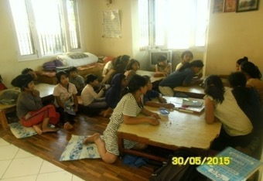
There are few girls in the street. However, once they are on the streets, girls are unfortunately much more vulnerable to any kind of abuse including sexual abuse. Therefore, it is essential to provide a safe place where they can benefit from socialization and rehabilitation services.
CPCS is running a center entirely dedicated to former street girls. Girls are directly referred from the street or from other NGOs and GOs to the Girls’ Center. Sometimes girls run away as they cannot handle staying in a closed environment due to drug addictions and bad habits. There are four girls in rehab. Currently, the Girls’center moved from Lazimpat to Godawari.Most of the cases referred by police in Rehab center are prostitute, domestic worker girls who could not stay long in the rehabilitation despite she takes other girls from rehabilitation. There are many cases come that the girl ran from rehabilitation center at night even daytime. Mos of the girl from the street have bad habits smoking drugs dendrite, street male fellow etc they cannot stay long in rehab.
RESULTS OF THE GIRL'S REHABILITATION PROGRAMS FOR JAN-DEC 2015
Month | J | F | M | A | M | J | J | A | S | O | N | D
No of children Beg |  |  |  |  |  |  | 6 | 5 | 2 | 2 | 6 | 6
New children | 4 | 5 | 3 | 3 | 3 | 3 | 4 | 0 | 3 | 6 | 1 | 0
F.R from office | 2 | 0 | 1 | 1 | 1 | 3 | 5 | 0 | 0 | 0 | 2 | 0
F.R through partners | 0 | 0 | 0 | 1 | 1 | 0 | 0 | 0 | 0 | 0 | 0 | 0
F.R after H.V | 1 | 1 | 1 | 0 | 0 | 0 | 0 | 0 | 1 | 1 | 0 | 0
Internal Referral | 0 | 1 | 0 | 0 | 0 | 0 |  | 1
Other Ngo Ref | 0 | 0 | 0 | 0 | 0 | 0
Drop out | 0 | 0 | 0 | 0 | 0 | 0 | 0 | 2 | 2 | 1 | 0 | 0
Nbr of children (end) | 1 | 0 | 0 | 0 | 0 | 0 | 5 | 2 | 2 | 6 | 5

Stories from girls Rehabcenter Godawari
Zeen thing (Name changed) is good and young girl. She is 10 yrs old. She is from Butwal Her general /physical condition is fair. She came in CPCS 25th –June-015, from National Center for Children at Risk (104).She came in Kathmandu with her sister in law for visit then she lost in Kathmandu valley. She never used alcohol, T.T injection, cigrate, dendrite e.t.c. she is only one daughter of family.
Her family status is normal. She wants to more study and her aim is Doctor. We knew about her, before one year she worked in kritipur as domestic girl worker. Then, we send for family visit with our staff, we didnot find her home. Now, she lives in CPCS. We provide her food, shelter and medical care etc. She don’t want to stay in CPCS so she wants to go back home. She will be sent home very soon.She has father and mother . Father is shopkeeper and mother is left for overseas job.
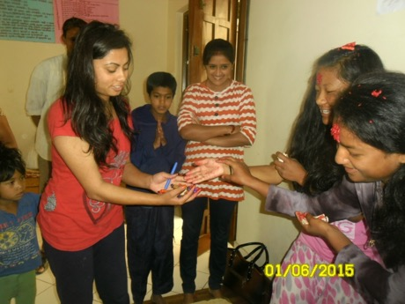
Geeta Rana (Name Changed) is young good. Her general /physical condition is fair. She came in CPCS organization 15th –Feb-014 on Sunday from field worker. Her family came in Kathmandu before 15-16 years ago. In this period, her father works labour. Her father and mother both are drunkard but she don’t use ciggarate, she hasn’t possibility go to back home because family economic condition is poor and large number of family member. Now, she stays in CPCS she wants to do more study and other facilities. Sometimes, she goes to back home for family visit like dashain, tihar festival and winter vacation.She is honest girl, study also good &involve to extra activities. In this condition, we send family reunification this is not better. She is studying class 3 at Sideshwor School GodawariHer fathe rmother is labor and she has a brother and sister. she is from Ramechhap and now she is living in Jorpati. She is 6 years old
Sita Lama (Name Changed) She came in CPCS from National Center for Children at Risk (104) on 07 Oct 2015. This is third or fourth time in CPCS of her. She runaway from CPCS thrice. After she runaway from here, she live at Maiti Nepal (Gaushala). After few months,.Maiti Nepal send back to home. She again come back Kathmandu with her sister in law at kandaghari. Her grandfather died after earthquake and father become crazy and mother also died when she was child. She don’t want to go back home. She want to stay in CPCS for sewing training but she don’t want to be more study. Her father married with sherpa woman. She is from Dolakha ghumkhola. She is 14 years old
The rehabilitation program for girls has been supported by the "American Himalayan Foundation" from the United States.

The CPCS Schooling Program
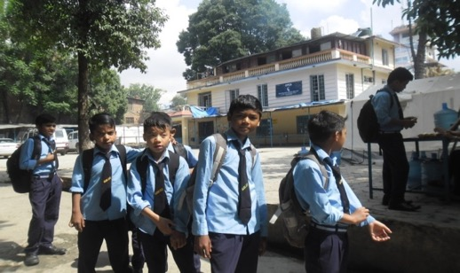
Due to family problems or lack of information on families’ whereabouts, family reunification seems tough for some of the street children. Therefore, CPCS has developed a schooling program in order to offer children services that have been adapted to their situation.
Through schooling, the children socialize, meet other children and get out of the street environment. It allows them to enter and be part of another community than the one of the street children. Children attend government schools and pass exams like any other student. They attend classes in Nepali, English, mathematics, social studies, sciences, and sports.

Most street children used to attend school in their hometown. However, because of illiteracy and other social problems, education is often not a priority in the countryside. This causes school absence and frequent drop-outs. In addition, the general level of education is very low in rural areas of Nepal. Additionally, the time children have spent in the street results in a great gap in their education. Hence, CPCS has developed good and close relationships with each of the schools that CPCS children attend. The teachers help CPCS social workers assess the level of the child and the class he should be admitted in. Note that CPCS is slowly decreasing its residential schooling support programs to focus on family reintegration and community-based care (see Master Plan). The Schooling Program supported by the American Himalayan Foundation and the Nick Simons Foundation since 2004 decreased from 110 to 84 students (in different CPCS centers) with students back home and others joining the rehab program.
Sn | Status in December 2015 | No
1 | Reunified with own family /community | 26
2 | Still attending the schooling program | 84
 |  | 110

The Dillibazar Schooling Center for boys
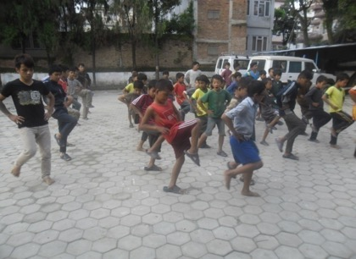
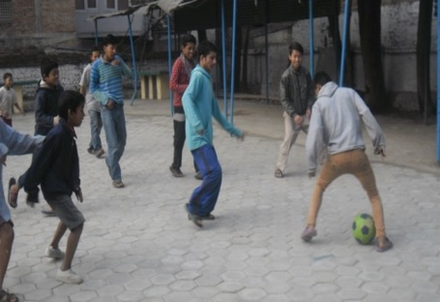
This center was established in 2004. The schooling program is one of the pioneer programs and there are currently 37 children enrolled in school from 10 to 17 years old. They all study in nearby government schools: Bijaya Memorial Higher Secondary, NandiRatri Secondary and Shivapuri Higher Secondary school. The children are doing well in school. The school starts at 10 and finishes at 4. Saturday and Sunday is the weekend. They attend school regularly.There are 7 youth student living in their own room.
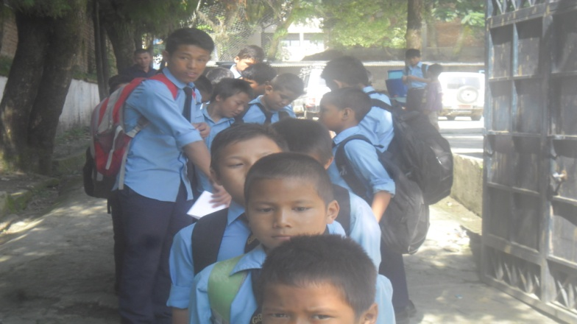
DILLIBAZAR BOYS SCHOOLING (ELITE) (JAN-DEC 2015)
Number of | J | F | M | A | M | J | J | A | S | O | N | D
Children attending school (beg) | 8 | 8 | 8 | 8 | 7 | 7 | 7 | 7 | 7 | 7 | 7 | 7
Children attending school (end) | 8 | 8 | 8 | 7 | 7 | 7 | 7 | 7 | 7 | 7 | 7 | 7

DILLIBAZAR SCHOOLING BOYS (SMALL SCHOOL) (JAN-DEC 2015) Below 14 years
Number of | J | F | M | A | M | J | J | A | S | O | N | D
Scholarised children (beg) | 14 | 14 | 14 | 14 | 32 | 30 | 30 | 27 | 27 | 26 | 26 | 24
New children | 0 | 0 | 0 | 0 | 0 | 0 | 0 | 0 | 0 | 0 | 0 | 0
Family reunified children | 0 | 0 | 0 | 1 | 0 | 1 | 1 | 0 | 1 | 0 | 0 | 0
Internally referred children | 0 | 0 | 0 | 19 | 2 | 0 | 0 | 0 | 0 | 0 | 0 | 0
Other Ngo ref children | 0 | 0 | 0 | 0 | 0 | 0 | 0 | 0 | 0 | 0 | 0 | 0
Drop out children | 0 | 0 | 0 | 0 | 0 | 0 | 2 | 0 | 0 | 2 | 2 | 2
Scholarised children (end) | 14 | 14 | 14 | 32 | 30 | 29 | 27 | 27 | 26 | 24 | 24 | 22
SCHOOLING BOYS DILLIBAZAR (SMALL SCHOOL) JAN-DEC 2015 Above14 years
Number of | J | F | M | A | M | J | J | A | S | O | N | D
Children attending school (beg) | 12 | 12 | 12 | 12 | 12 | 12 | 13 | 13 | 13 | 9 | 9 | 9
New children | 0 | 0 | 0 | 0 | 0 | 0 | 0 | 0 | 0 | 0 | 0 | 0
Family reunified children | 0 | 0 | 0 | 0 | 0 | 0 | 0 | 0 | 2 | 1 | 1 | 1
Internally referred children | 0 | 0 | 0 | 0 | 0 | 0 | 0 | 0 | 0 | 0 | 0 | 0
Other Ngo ref children | 0 | 0 | 0 | 0 | 0 | 0 | 1 | 0 | 0 | 0 | 0 | 0
Drop out children | 0 | 0 | 0 | 0 | 0 | 0 | 13 | 13 | 9 | 8 | 8 | 8
Children attending school (end) | 12 | 12 | 12 | 11 | 11 | 11 | 9 | 9 | 7 | 2 | 2 | 2
Out staying youth | 6 | 6 | 6 | 6 | 6 | 6 | 0 | 0 | 0 | 0 | 0 | 0
Residential youths in school | 1 | 1 | 1 | 1 | 1 | 1 | 4 | 4 | 2 | 6 | 6 | 6
Above 14 in School | 5 | 5 | 5 | 4 | 4 | 4 | 13 | 13 | 13 | 9 | 9 | 9

Stories from Dillibazar Schooling Program
Bijay Adhikariis from Birgunj. His father passed away and his mother eloped with another man and is now begging in Dakchin Kali. His sister is also unknown. His 2 stepbrothersare also begging in the temple. A woman called Kamala Maharjan gave him shelter for four years. He gave him her surname. Her son is disabled. After four years, he was sent back to Birgunj because he could not stay there. He came to Kathmandu with his mother.He could not continue to study because he had no money. He left his mother and in the street, he met somebody whi took him to CPCS. This was six years ago. Now he has completed SLC with 82 percent distinction.In 2013 he went to his house and made a birth certificate.He is planning to study hard in the future and become a good person. His ambition is to become Carter Accountant. He is hard working devoted person and helpsother children to study too.
Diwakar Rautis 15yrs old now He has mother father younge rsister and younger brother. He ran away from house and came to street and contact with cpcs fieldowrker 5 years before. He ran away from home becasue his family could not fulfill his demand now he is studying in class six and he join school since 2012In future he wants to become mechanics. He was abused by father so he dont ant to go home and stand his own .

Schooling Center for Girls at GODAWARI

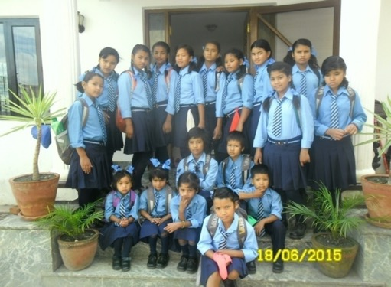
There are 19 girls attending school at Siddeshwori lower secondary and Kitini Higher Secondary School from the Girl’s Center in Godawari. From ages4 up to 19, they study in classes 1-12.The previous girls’ center was located in Lazimpat. Because of bad drainage and the lack of sufficient rooms, the girls’ center moved from Lazimpat to Godawari.
The present Girls’ Center in Godawari is in a village locality and surrounded by a natural environment. It is 100 meters north from the road to Godawari The girlsparticipate in many activities such as dance, music and other extra-curricular activities. It is in a residential area and very safe for the girls. Most of the girls in this center are from underprivileged families and have street backgrounds. They are very aware of health, safety and hygiene. The girls themselves keep the center very clean, tidy and nice although the house is relatively small.
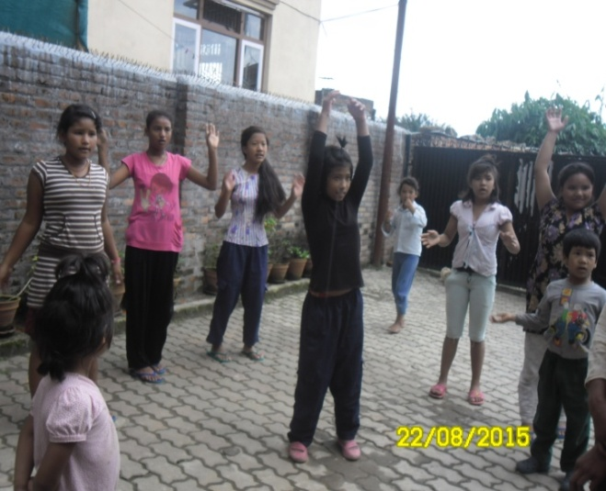
Some of the girls were reunified with their family and some girls visit the family and came back to continue school. It all depends on the family situation. The girls organise excursions as well. They visit heritage sites as museums, the zoo, and swimming pools. They live in harmony. They share and care for eachother.

GIRLS SCHOOLING PROGRAM GODAWARI JAN-DEC 2015
 | J | F | M | A | M | J | J | A | S | O | N | D
Children attending school (beg) | 17 | 17 | 17 | 16 | 19 | 19 | 19 | 19 | 20 | 20 | 20 | 20
New children | 0 | 0 | 0 | 3 | 0 | 0 | 1 | 1
Family Reunified children | 0 | 0 | 1 | 0 | 0 | 0 |  |  | 0 | 0 | 0
Internally Referred children | 0 | 0 | 0 | 0 | 0 | 0 |  |  | 0 | 0 | 0
Other Ngo Ref children | 0 | 0 | 0 | 0 | 0 | 0 |  |  | 0 | 0 | 0
Drop out children | 0 | 0 | 0 | 0 | 0 | 0 |  | 1 | 0 | 0 | 0
Children attending school (end) | 17 | 17 | 16 | 19 | 19 | 19 | 20 | 20 | 20 | 20 | 20 | 20
The Girls Center is supported by the American Himalayan Foundation

The Youth Program
Many former street children are above sixteen and referred to the youth program. Because they are going through adolescence, they deserve a specific kind of attention. They need to be given responsibilities and to be fully involved in their rehabilitation process for it to be a success. Youths of this age who have spent time on the streets are likely to engage in delinquency or criminal activities.
The Youth program was developed with the idea of delivering services and means of intervention tailored to youths’ particular needs. CPCS does so by giving responsibilities and guidance towards the youth’s professional life and future according to their literacy, educational background and wishes. Among the different means of interventions, CPCS encourages youths responsibility and participation in daily work life, discussion groups, and the possibility of working as a volunteer. Through the Youth program, youths can choose among different services involving a set of activities among which you find:
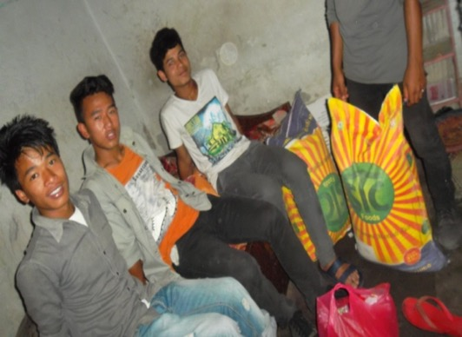
- Involvement in CPCS programs; tuition, office support, help in the kitchen. Besides common activities, youths have the possibility to choose between different options. The CPCS Youth program runs over five levels leading them to become a social worker. Through this program, youths are given progressive responsibilities within CPCS centers and programs. They can become a Junior Social Worker, then an Assistant Social Worker before becoming a Social Worker. The CPCS Youth program also offers alternative solutions for youths whose interests are not to become social workers.
- Getting involved in a vocational training in various fields (Electricity or mechanics for example) through partner organizations among which you find Shangri La Home, Aarubari (main working partner of CPCS for youth support) or the Gokharna Training Center.

There were 16 youths enrolled in the CPCS Youth program in 2014. 2 youths have been placed in hotel jobs. There are 3 youths who have settled in their own rooms and stay out of the CPCS shelter. A youth girl attends beautician training in Maharajgunj, 6 months practical and theoretical courses.

CPCS has organized a three days closed camp for youths to motivate and talk about their family, personal life, skill training, vocation center, personal hygiene, personality, citizenship and personal identification. It was held on different dates, which covered 50 youths from the street and from rehab centers. They learnt many things there; life, family, society, education, career, training, health etc.

Stories from the Youth Program
Ram (name Changed) from Chitwan has a brother and a sister. Five years ago, his father sent him to CPCS in Narayangat. His mother married another man, his sister was working as a caretaker in someone’s house. His father consumed alcohol. We have no information on where they are now. When CPCS in Narayangat closed, he came to Dillibazar. He participated in different song and art competitions in school and other places.He came to Bishalnagar Center on 26 September 2011 in the elite Program and studied in Sivapuri School class 4. His last year, he passed in first division 74.63%, 23th rank in his class, his class teachers are very happy because his performance is very good in all subjects.Last week,he received the first prize in art competition in class. His voice is also good. Every day he practices singing, and knows many songs. He is interested in playing football, badminton, tablet tennis, etc… He is one of the very good boys in Bishalnagar Center He is very obedient, respectful and friendly to all. He is also very gifted, even without proper training he is doing very well. His future looksbright;his first aim is to be an artist and second to become a top singer in Nepal. After following training on Mountain View art, he will able to sell his paintings in the Market. In order to improve in all his arts he needs more training.
AnandaTamang (Name Changed) was from sindhupalchowk sunkhani and he raised and cared in CPCS since his childhood along his sister and brother. He is now turning 17 yrs. Now his brother and sister left CPCS and he is living in CPCSand get support for schooling. Once he ran from CPCSand worked out but he couldnot continue again he joined CPCS. He is living in room with friend in CPCS support He involved in CPCS and take sinformal training and work as peer educator..
The Youth Program was supported by Ecpat Luxembourg, then mixed support from various donors (including Caritas)

Dolakha Rehabilitation Program Dolakha
Dolakha rehabilitation was established duly after quakes considering risk among children. It is located in Bhimeshwor -10, Simpani where 3 stories building with 14 rooms can occupy about 30 children. Currently there are 9 children are rehabilitating over there. Most of the clidren flee from home because of many problems; earthquakes, poverty, family violence, family conflict mother elope etc. The children referred from other partnwers NGOs, government bodies.
 |  | July | Aug | Sep | Oct | Nov | Dec
 | Nbr of children (beg) | 0 | 1 | 0 | 4 | 4 | 6
 | New children | 2 | 10 | 13 | 6 | 5 | 5
 | F.R from office | 1 | 11 | 3 | 6 | 3 | 2
 | F.R through partners | 0 | 0 | 0 | 0 | 0 | 0
 | F.R after H.V | 0 | 0 | 0 | 0 | 0 | 0
 | Internal Referral | 0 | 0 | 6 | 0 | 0 | 0
 | Other Ngo Ref | 0 | 0 | 0 | 0 | 0 | 0
 | Drop out | 0 | 0 | 0 | 0 | 0 | 0
 | Nbr of children (end) | 1 | 0 | 4 | 4 | 6 | 9

Dhannsari gurung (Name Changed) is 12 yrs old .she is from Suri . She has fathe rand mother. Her school name is Shree Halesuri higher Secondary school Gadibu-6, Dolakha. Her school principle name is Hari Chandra Yadav. She likes her school and school teachers. He was very good and honest. Her school starts on class 1 to 10. Her school is very that why she like to go school. In her school the government provide budge for the poor students. She has one big brother which is studying in grade 9 and and small sister studying in grade 2 She is from dolakha . Her family occupation is farmer they grow up different types of crop like vegetable, wheat, potatoes, and etc. Her family actual income is 30 thousand only per year. she has a younger ssiter and elder brother She wants to be a good teacher in future and study higher class then she goes to out of country for the job.
Sita Thapa( Name changed) is 14 years old from SuriHer school’s name is Shree Halesuri higher Secondary school Gadibu-6, Dolakha. . Her school principle name is Hari Chandra Yadav. She likes her school and school teachers. He was very good and honest. Her school starts on class 1 to 10. Her school’s teachers are nice because they never dominate and never shouting and beating. Her school time table is very good. Her school is government school so it have been government facility. There is 8 members in her family. Her family occupation is farmer but her father never comes home because her father went to Kathmandu for work and her mother is house wife. Her family income is 25 thousand per year only. she ahs elder brother younger brother elder sister mother and father She wants to study in future and then she wants learning tailor. She is interest in tailor. So she is thinking about tailor.
Ramesh Singh (Name Changed ) is 9 years old boy from julu dolakha, In his family Father , Mother and one grand mother only. But his father and mother has not good personal relationship. Father also disable and mother already went to her mother house then he has mental disorder(learning disability).his grand mother also so old, she can not care him.Their economical condition also not good. He read in class 2 on julu. So that grand mother hand over him on DCWB and DCWB referral him to cpcs for mid term rehabilitation. he is from julu

Dolakha Building Construction
It has started since 18 February 2015. It was planned to construct two stories building, last earthquakes revised its plan and conclude to construct two one storied building and one recovery center. Earthquakes 25 April and 12 May 2015 damaged building site, which was totally collapsed whole construction site. CPCS paid compensation to the contractor. The centre will be a rehabilitation centre and a regional office supporting all 600 families in the district.
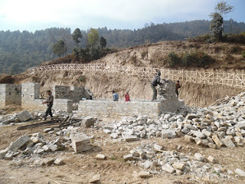
Next contract was done in July 22 2015 although it was seriously affected by Indian economic blockade. Now it resumes work like compounding, gardening etc. Most of the building construction materials price hikes and shortage in market. Now it resumes work of stone collecting,gardening, compoundwall, lebelling the land. CPCS has planted tree and fruits. The center will be ready by 2016 and the buildings/project are supported by various donors (Amis de Soeur Emmanuelle, monsieur Duez, SALAAI, EUcanAID, Vie d’enfant, la foundation Vieujant, l’école INDSE, CPCS-France, etc…) (ask the specific report if interested)

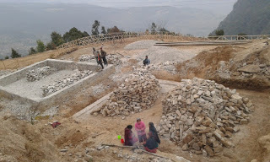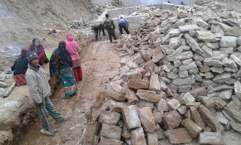

CPCS Management

The CPCS team
The team at CPCS is composed of 79 professionals; some of them are former street youths. The following personnel manage the team and the departments in different NGO’s under the CPCS-Alliance Umbrella.
Position | Name
International General Director (CPCS- INT) | Jean-Christophe Ryckmans
Country Director (CPCS- INT) | Inge Bracke
General Director (CPCS NGO)- Administration and Finance | Himmat Maskey
General Director (CPCS- INT)- Program | Bijesh Shrestha
Deputy Country Director (CPCS- INT) | Arjun Mohan Bhattarai
Program Director (Legal) | Hem Bahadur Budhathoki
Center Director (Sifal) | Aitaraj Limbu
Financial Manager | Tek Bahadur Paudyal
National Director (Prevention and CLASS) | Nawaraj Pokharel
National Director (Monitoring Evaluation Partnership) (CPCS-INT) | Ekta Narayan Pradhan
Center Director (DolakhaRehabilitation) | Badri Prasad Sharma
Deputy Regional Director | Bimala Khanal
Program Coordinaotr (Medical) | Padam Adhikari
Center Director (Emergency Home) | Surya Prakash Shrestha
Center Director (Dillibazar schooling Rehabilitation) | Puran Sakya
Deputy National director Prevention | Ranju Shrestha
Deputy Program Coordinator (Prevention) | Sanu Maiya Shrestha
Senior Program officer (Girls) | Srijana Sapkota
Senior Program Officer Prevention) | Kishor Lamsal
LSA and Expert (Public Relation) | Dabal Pandey
Deputy Center Director (Sifal Socialization) | Kailash Rawal
Driving Officer (Senior) | Krishna Prasad Dhital
Position | Name
Driving Officer | Rhabi Bhandari
Deputy Center Director (Dillibazar rehabilitation) | Badri Narayan Shrestha
Program Officer – Socialization | Nabaraj Baniya
Program Officer - Dolakha Rehab | Bhagat Prasad Shiwakoti

The CPCS Administration System

The CPCS Administration System has devided into the Board of Directors and the Executive Management Committee. The organization gathers a variety of expertise in different areas: legal, social, fieldwork, administration, management, and medical. The employees work in different shifts (morning, mid-day and evening) in different centers and programs ensuring services from dawn to dusk.

The CPCS Board of Directors
The Board of Directors is responsible for prevention, development, education, promotion, out of valley, street children shelters, fieldwork, girls at risk protection, boys at risk protection, and rehabilitation. The Board of Directors is made up of 13 members. Six positions are reserved for community representatives; one member from CPCS International; the CEO, and the remaining three seats are assigned to the CPCS management staff. The Board meets once every three months and monitors the decisions made by the management team, keeping in mind the philosophy and objectives of CPCS. The board may revise a decision taken by the management team.

The Executive Committee (CDC – Central Direction Committee)
This committee is the government of CPCS, mandated by the Board of Directors to ensure the overall coordination and daily management between the different centers and divisional directors. The Committee makes decisions discussing different subjects: the implementation of the Board of Directors’ decisions, the coordination and efficiency of CPCS projects, centers and programs, the suitable way of communicating information to the entire team, and the Human Resources Management. They organize a meeting once a week. Proposals of meetings are submitted in the executive board for approval. Since last 2015 CPCS organizes its meeting in formal way and participation also increased in the meeting. the members provided suggestion and feedback on managment proposal

The Staff Meetings
Once a week, the staff from all the centers has a meeting with the children “ministers”. It is essential for the information to flow properly from top to bottom within the hierarchical pyramid, and vice versa. Each staff member is allowed to speak and all the children elected by their peers to represent a program at the meeting are present. CPCS frequently organized internal training for staffs about Child policy by our lawyers.
On 5 October,CPCS organizedtraining for CLASSLSA fromKathmanduvalley there were 12 LSa particiapted in program. The training covered the issues, child right, objectives of CLASS program, child rights. CPCS provides NCELL sim among 83 staffs for communication where they can call freely

The Children Participation
CPCS has created a children’s central government. Government members are elected democratically by all the children and meet every Friday in Dillibazar. These meetings give the children the possibility to bring any topic they want on the table and to make suggestions about the program they are enrolled in. Those meetings take place in two different phases. First off, every child has a chance to give its opinion about its own center. Secondly, there is an in-depth discussion about different ideas or comments that were brought up by the children during the first round of the meeting.For every meeting the government members write a report about what was said and about possible actions that need to be taken in the future. To ensure that the rules and the system are respected, the children have formed a court of Justice to ensure that the system works and that the rules are followed properly and correctly.
By making the children participate in the life and management of the centers, we try to make them feel responsible and offer them a role to play in our structure.The objective of this government is to make the children aware of the management of the centers and their daily lives and to teach them how society works. The CPCS staff facilitates the meeting: Tej Karki and Badri Psd Sharma.
Other examples of children participation:
The Kitchen Club that exclusively takes place in the girl's center illustrates the participation of the children in the centers. In 2006, CPCS opened a canteen system for the meals and snacks managed by a subcontractor. It was not a great success and many children complained about the food quality.
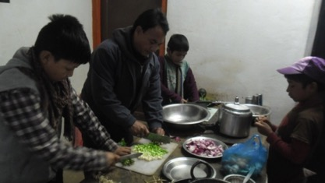
Consequently, the Kitchen Club replaced the canteen at the beginning of 2007. Every day, two children from the Kitchen Club have to prepare rice, lentils, and vegetables for the other children and the members of the organization. Each group is responsible for purchasing food at the market, for keeping accounts, and for the cleaning. Particular attention is paid to the safety and quantity of food in stock, what is distributed, and thrown away. It is the role of the children to be creative and care about the kitchen area, including hygiene and the look of the kitchen. The kitchen club system is currently being revised.
DASHAIN TIHAR FESTIVAL CELEBRATION IN CPCS 2015
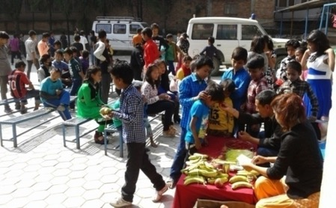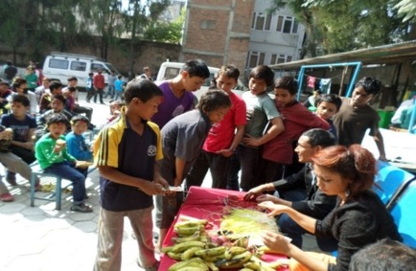
President Bijehs srhestha offered tika to the children at dillibazar in Dashain Day
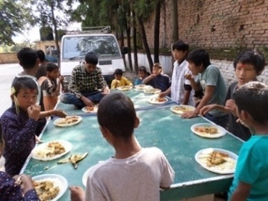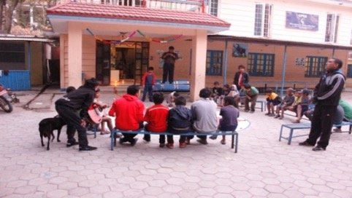
Children are enjoying lunch after Tika and perfoeming Daushi bhailo during festival of light
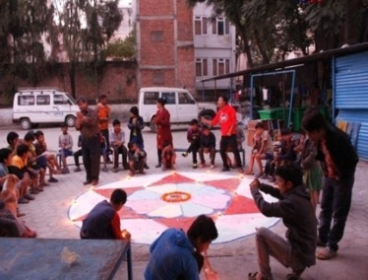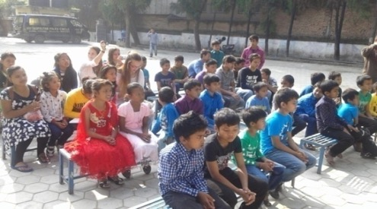
Children are making mandala to welcome goddess laxmi in ndillibazar cpcs premises and dance shoolThere are more than 180 children have particiapted in Dashin celebrstion in Dillibazar. During Dashain day they have delicacies sweet fruitts chickedn and rice. They put tika from presdient. Same way during Tihar they take tika from sibling brotehr sister. Both festivals they celebrated together in Dillibazar.
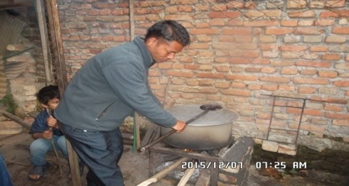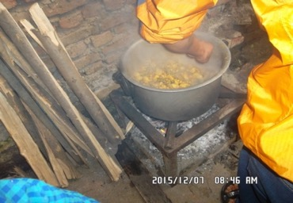
During fuel crisis , social worker prepared meals for children in firewood at Dillbazar Center
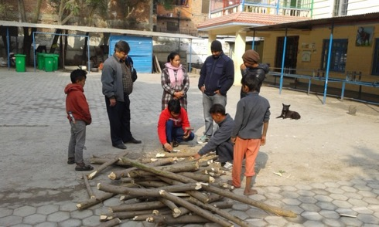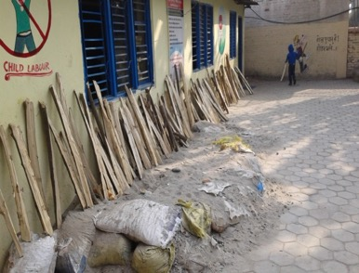
Firewood pieces and log piled up in yards and make dry in sunny days at dillibazar
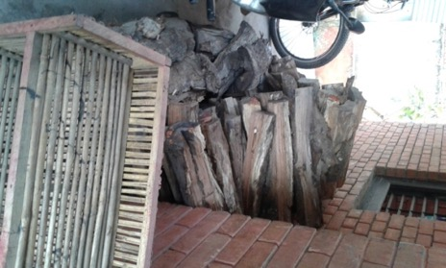Pil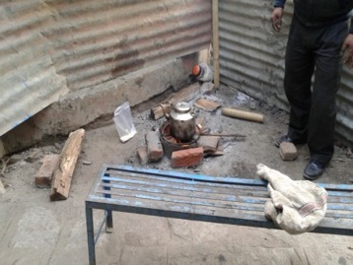
Piled up firewood in Sifal center and putting kettle in firewood furnace in Sifal Center
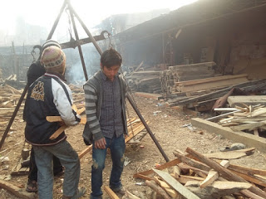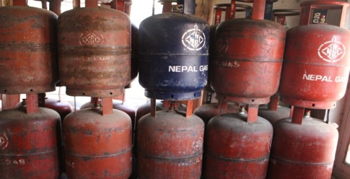
One side firewoods are weiging amnd other side empty gas cylinder

Child Council meeting JAN-DEC 2015
Representatives by Center | J | F | M | A | M | J | J | A | S | O | N | D
Dillibazar | 20 | 24 | 18 | 4 | 0 | 24 | 20 | 16 | 20 | 10 | 6 | 20
Girls | 10 | 9 | 6 | 2 | 0 | 12 | 9 | 6 | 7 | 2 | 2 | 4
Sifal | 7 | 4 | 4 | 2 | 0 | 10 | 6 | 5 | 6 | 2 | 3 | 4
No of participants total | 37 | 37 | 28 | 8 | 0 | 44 | 35 | 27 | 33 | `14 | 11 | 28

Suggestion box in centers
CPCS has a suggestion box in every center where children can put their comment, critics and/or suggestions for CPCS. The box is opened every month with representatives of the children, a lawyer and the President. The proposals are submitted during CDC meetings for implementation. Most of the improvements brought to the programs come from the children’s own suggestions.

Networking with Authorities State Bodies and other organization
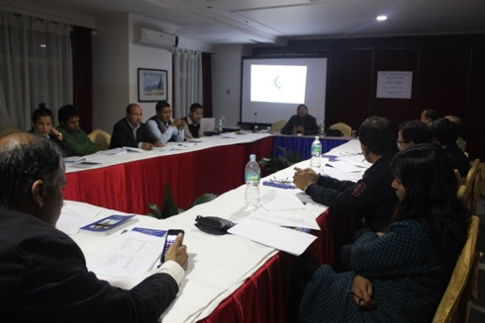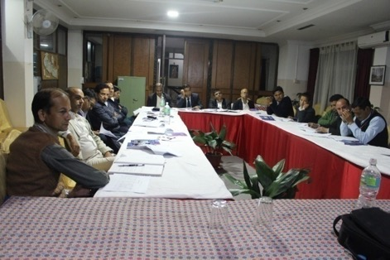
CPCS regularly participates and attendsmeetings with NGOs, CBOs, GOs and INGOs. CPCS organized a CPAC meeting which was chaired by Er Rabindra Kumar Member Secretary SWC. Representatives from the Ministry of Women, Children and Social Welfare also participated in the meeting. The meeting suggested and highlighted the need of some policies; HR policy, Financial policy, proper appropriation of administration and program budget, coordination with local bodies and the need for assessment of the programs as well as stakeholder selection.
CPCS demonstrated the street drama, “child sexual abuse “in different schools such as Surke and Tamakoshi.
Saint Xavier College sent their A-level and BSW students as interns to CPCS centers. They are involvedby supporting the children through activities, homework, tuition and other extracurricular activities daily.

Networking with NGOs and other Child Protection Organizations
CPCS believes in collective efforts on different levels to enhance the CRC (Child Right Charter) implementation and solidarity of working together for the welfare of the children. As mentioned in this report, there are many organizations that CPCS collaborates with. Underneath are some examples:

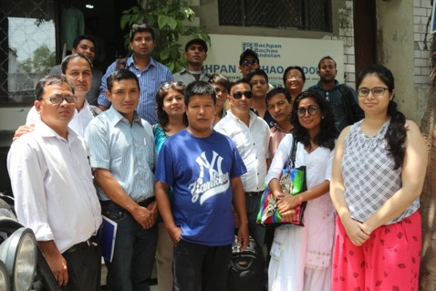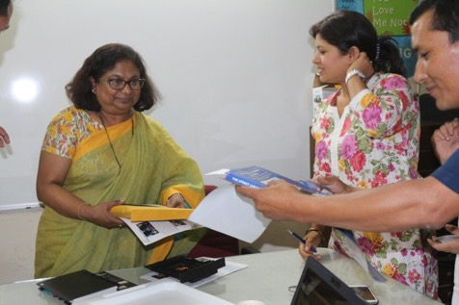
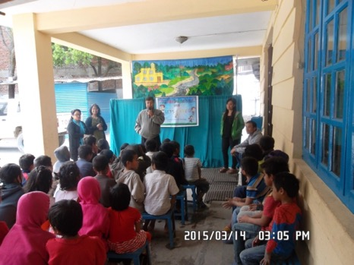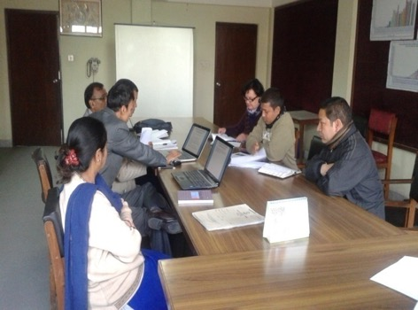
President Bijesh Shrestha and and program officer Kailash Rawol recently visited India in field workers meeting in June 2015.

- CPCS has developed a partnership with the Central Child Welfare Board (CCWB)
- Coordinate and collaborate with Kids Shangrila, Jyoti Vocational, CWSN through referral youths for life skills and vocational trainings.
- Regular coordination with Balbalika Khojtalash Kendra 104 (Center for Children Search and Found) whose mission is to find the children’s’ families and inform about the children that do not know their home address and try to reduce the risks of violence, abuse, or exploitation of children.
- Collaboration with Shivapuri Higher Secondary school, Gyan Bikash school, Bijaya Memorial high school, and Nandi secondary school who have been managing the enrollment of CPCS children in schooling programs and offered support for their academic growth and development.

CCWB, Central Child Welfare Board called meeting to rehabilitate children from Kathmandu Street and proclaim to street children free Kathmandu. There are series of meeting held in ministry of woman children and social welfare MOWCSW and CCWB with working active Ngos for consultation and partnership. Ministry and CCWB already made the guidelines to regulate and monitor the street children work in Kathamdnu Valley. During the meeting, there were CWIN, SAATHI, SATHATH, PRAYAS,KHUSHI VOICE OF CHILDREN CONCERN HEARTBEAT ngos who works for street children. CCWB team already visited CPCS sifal shelter and propose to increase capacity to rehab more children
CCWB Street Children Desk Chief Mr Rabi Gautam has visited CPCS and went for night field and watch CPCS night feild program for few days. Same time he has collected the number of children met in the street.
On 22 dec 2015 President Bijehs shrestha gavepresentation about street field workers forum in Siddhartha cottage programw as organized by Khushi Nepal and other NAOSC members aslo present.
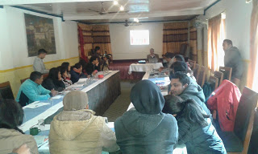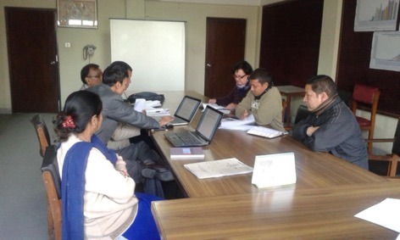

CPCS MADE DOCUDRAMA LAUNCHING PROGRAM 2015
Former minister Dr Minendra Rijal at Indreni Banquet premiered Manu dev docudrama onSeptember 15 2015. This docudrama was made by All3 Media ghar for CPCS, which was funded by ECPAT Luxemberg. Program was organized by CPCS . During the program CPCS international Director Jean-chirstophe Ryckmans shaded light about CPCS program. Program was anchored by Nawaraj Pokharel and presided by Bijesh shrestha. Program was followed by dinner.125 children and 35 staffs watched the docudrama. Supported schools teachers and other dignitoried from GOs and NGOs were also particiapted in program. Program was run for 3 hours. altogether 250 people have particiapted in program. Minister Rijal honoured the actor and actress bijaya regmi and Alisha bhujel..Lucky Gurung (AIN), Mirgendra Karki (TU Dept social work )Madan Rimal (SWC) Ram sharma (SWC) Sita Pariyar (MOFAALD) Bimal bhattarai ( Morang Samaj president) and CARITAS International Director also invited in the program.
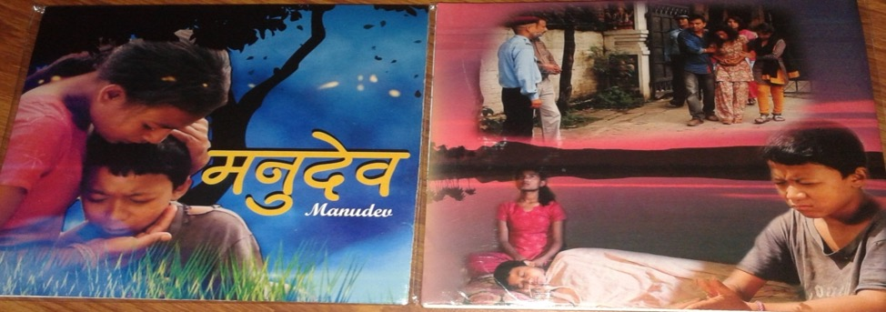
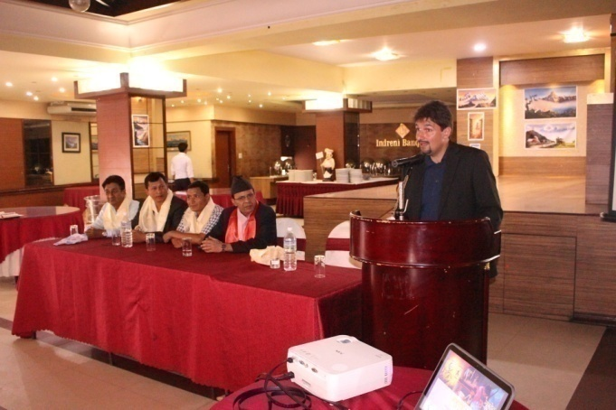

Outlook for 2016 (Jan to December 2016)
- Reinforce the programs “Rehabilitation” and “Young People "according to the new system with arrangement of rooms outside of the CPCS facilities
- Deinstitutionalizemany street based children/children at risksand develop the process to ensure reinsertion of children in their families.
- Improve the legal medical emergency line all over the country and street children support out of the valley (Kathmandu) services and focus on their legal documentation.
- Improvethe CPCS structure (board, CDC, management) – with multiple local partners and develop and International Alliance (The CPCS Alliance)
- Reinforce our link and partnership with local authorities (DDC, SWC, CCWB, MOWCSW)
- Improve the implementation of CPP among staffs, children etc.
- Start the Dolakha Rehabilitation Project
- ImproveDillibazar, Girls, and procurement of office equipment
- Build Godawari Rehab center to shelter Girls (rehabilitation only short/mid term) and under 12years boys.
- Establish New emergency rehab centers (Sindhuli and Morang) with local partners
- Implement and make new HR policy / Financial Policy and Child Protection Policy
- Adopt new strategies/methodologies to continue working with street-based kids (opening of a street-arts/rehab shelter in DB (and closure of Siphal)
- Ensure appropriate locations for all CPCS staffs with a strong focus on “Regional structures and programs support”

