CPCS

Child Protection Centers and Services

Child Protection Policy

2019-2020

1. Introduction:

CPCS (Child Protection Centers & Services) has been working for the protection and the rehabilitation of street children and children at risks in Nepal since 2002.

As a result of domestic violence, poverty, job searching, natural disaster among other social and economical issues and an increasing urbanization, children migrate from the home town to the cities where they frequently end up in the streets and discover its dangers. There, they often suffer from drugs, crimes, hatred, exploitation, discrimination and abuses.

CPCS was created to support these children and youth and to prevent more children from ending up in the streets.

The organization’s work can be divided into three steps:

- Prevention (prior to and during the street life) : set of interventions focused in two ways:
- prevent and, if possible, avoid the arrival of the child in the street
- create awareness among general public, the families and the children themselves on the realities of life in the Street (its causes, its daily routines and its consequences).

- Risk reduction (during life in the street) : short term perspective focusing on immediate reduction of the dangers of street life .

- Social rehabilitation (after life in the street): long term perspective focusing on progressive and eventual reintegration of a child into society.

CPCS is committed to protecting children from any kind of abuses and to ensuring the fulfilment of their rights.

This Child Protection Policy has the following objectives:

-To prevent any kind of abuses inside CPCS Centers

-To ensure promotion of child rights and appropriate guidelines for the personnel

-To prevent false or malicious accusations of abuse

-To ensure CPCS has a “child friendly and safe” environment

2. CPCS – Vision, mission and objectives:

-Vision :

CPCS works for a society where all children are respected, valued and protected.

-Mission :

CPCS mission is to deliver basic services (medical, legal, psychological, educational, etc.), bringing immediate improvement to street based children and children at risks.

-Objectives of CPCS :

  - Develop services directly on the street to offer protection to street based children and to reduce the risks they are exposed to.
  - Develop services allowing street based children to take a step forward toward their reintegration in society and in their family.
  - Develop prevention programs to prevent more children from coming to the street.

  - Take on the children’s problems with understanding and respect, considering them not as victims or delinquents but like people with diverse skills.
  - Be a bridge between the street and society.

  - Reduce risks that the children face when they are in the street.

  - Give the street based children basic education, attention and support.

  - Protect the children’s fundamental rights.

  - Raise awareness on street children’s situation in Nepal and abroad.

  - Give the children access to healthcare and hygiene services.

  - Reintegrate the children in their community, and reunite them with their families.

  - Reduce and progressively abolish all forms of child exploitation.

  - Fight against some of the worst forms of child labor.

  - Mobilize communities, organizations, institutions, and families to better meet the children’s needs.
  - Contribute to enforcing the Child Act (1992), legal support for children in the streets.

3. Scope and Definitions under the Child Protection Policy

-Scope :

The CPCS Child Protection Policy applies to all CPCS employees, CPCS visitors, CPCS volunteers, CPCS board members, whether paid or unpaid, full time or part-time having direct or indirect contact with children. All must comply with its requirement and this commitment will be evidenced through signing the policy.

-Definitions :

1. As per the article 1 of the United Nations Convention on the Right of the Child (CRC) ratified by Nepal on September 14, 1990 : “A child means every human being below the age of 18 years”.

2. Street Children :

The European federation of street children defines street children concept as such : “extremely vulnerable group of children living in most severe situations well beyong the usual notion of poverty. They face a gross violation of their human rights, such as violence, sexual exploitation and abuse, chemical addictions, and numerous other human rights violations.”

At CPCS while still using the concept “street children”, we are really careful about the risk of “stigmatization” of the concerned children by a rigid and too simplistic definition. (reducing them as a disease that has to be treated)

- Child abuse is defined as all forms of physical abuse, emotional ill-treatment, sexual abuse and exploitation, neglect, negligent treatment, commercial or other exploitation of a child and includeds any actions that result in actual or potential harm to a child.

- Child abuse consists of anything which individuals, institutions or processes do or fail to do, intentionnaly or unintentionnaly, which harms a child and damages their well being, dignity and prospect of safe and healthy development into adulthood.

- Physical Abuse: This may involve hitting, shaking, throwing, burning or scalding, drowning, suffocating, or otherwise causing physical harm to a child. Physical harm may also be caused when a parent or carer feigns the symptoms of, or deliberately causes, ill health to a child who they are looking after.

- Emotional Abuse: This is the persistent emotional ill-treatment of a child such as to cause severe and long lasting effects on the child’s emotional development. It may involve conveying to children that they are worthless and unloved, inadequate, or valued only so far as they meet the needs of another person. It can also involve age or developmentally inappropriate expectations being imposed on children, or causing

children frequently to feel frightened or in danger. Some level of emotional abuse is involved in all types of ill-treatment of a child, though it may occur alone.

- Neglect: This is the persistent failure to meet the child’s basic physical and / or psychological needs, likely to result in the serious impairment of the child’s physical or cognitive development. For example, inadequate care and supervision which leaves a child in a dangerous situation where they could be harmed (but only where this can be avoided).

- Sexual Abuse: This involves forcing or enticing a child to take part in sexual activities, whether or not the child is aware of what is happening or gives consent. The activities may involve physical contact, including penetrative (e.g. rape) or non-penetrative acts. They may also include non-contact activities, such as involving children in looking at, or in the production of, pornographic materials or watching sexual activities, or encouraging children to behave in sexually inappropriate ways.

- Other types of abuse commonly recognised, such as commercial sexual exploitation and trafficking, are complex manifestations of a combination of the above four categories. It is important to highlight that bullying is also a form of abuse as it is an act of aggressive behavior in order to intentionally hurt another person or persons, mentally, physically and/or sexually. Abuse can take place in many forms and anywhere, that is, in the family, community or on the Internet. Abuse is also manifesting itself in digital and augmented technologies such as smart phones. This can be virtual or real and can take many forms including sexual harassment and child pornography. It should be remembered that although we commonly think of adults as those who abuse children, children can also be the perpetrators.

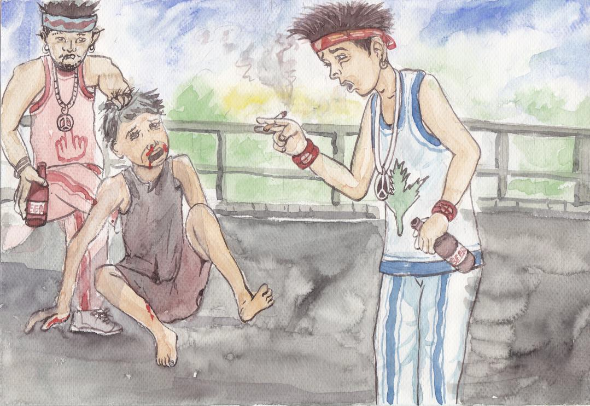

Belief, Principles and values defended by CPCS :

-Belief :

The belief at CPCS is that the first step towards the rehabilitation and reintegration of children in street situation involves risk reduction, which is comprised of short-term actions to reduce the dangers of street life.

Doing "risk reduction" can sound like too little ambitious, fatalistic, as if we dedicated street based children to an inevitable and immutable reality. Critics on the dangers of the facilitation of the street life are numerous and often appropriate. The shelters or "dropping centers" are often criticized around the world by international or local organizations that prefer field action, direct rehabilitation, prevention or prohibitive actions, trainings,…

It is a fact that the shelters exist neither to “store” the children nor to leave them in their condition. Nevertheless, we are convinced that the shelters, in Nepal like elsewhere, can be a place of continued learning, of informal or technical education, of civic rights and duty training, a place of welcome, of listening, a place where to rest, to get food and a possible bridge to a reinsertion into the family and school.

Working on "risk reduction" certainly takes makes much sense in Nepal, if we consider a simple fact: many street based children will remain on the street and more than 50% of the remaining children will join society at a low or very low social level.

Moreover, we are convinced that it is important to give the children simple but necessary tools permitting them to survive and even to live in an environment that will never be easy. To learn how to read, to write, to count, to be aware of their rights, to know what the society means by good and wrong, to be able to live with other people, to avoid drugs, prostitution, alcoholism, violence… To have an access to medical care, some basis of hygiene, self-respect, to have a warm place where to sleep and get food: these are the educative and practical components that we must provide with each child.

The "risk reduction" program focuses on these last points, and we hope that we will be able to do more for the children in a second step and that, taking into account their ways, their desires and choices, it will be possible to bring them back to school, to their family, society…

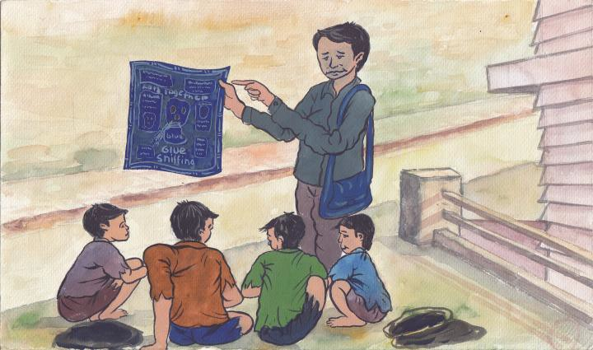

-Principles and values :

CPCS is strictly non-political and non-religious and will not at any time promote or support any political party or religion above another.

CPCS respect the beliefs and tradition of all its beneficiaries.

All CPCS projects are child-centered and child-focused and all decisions are taken for the best interest of the children and youth.

CPCS work is carried out in full respect of the beneficiaries’ gender, religion, ethnicity, origin, health, legal or social background.

CPCS is strongly opposing the stereotypic images of victimized children and “pity charity” CPCS beneficiaries have full freedom to make decisions about their own lives
CPCS commitment to child protection is guided mainly by the CRC following articles used as a basic principles of this child protection policy and CPCS’s work as a whole:

Article 2 (CRC) : “Children must be treated… without discrimination of any kind, irrespective of…race, color, sex, language, religion…or other status”

Street based children and youth should not be discriminated against by individuals from other social classes because they are different; they don’t live in a house, they don’t enjoy family protection, and they have to work and survive in dire conditions”

Article 6 (CRC) : “Every child has the inherent right to life…survival and development”

The right to live, the right to be and the right to develop properly should not be distant dreams for the street based children and youth.

Article 7 & 8 (CRC) : “The child shall… have the right… to a name…a nationality…and to preserve his or her identity”

Street based children should get identity cards. Their own name, age and address should not be changed for any reason by any authority. They should have a legal existence.

Article 24 (CRC) : “All children have the right to the highest attainable standards of health… (including access to) primary health care… nutritious foods and clean drinking water.”

Street-based children should have access to basic health care facilities.

Article 27 (CRC) : “Every child has the right to a standard of living adequate for (his/her) physical, mental, spiritual, moral and social development.”

Living on the street, children must sleep and live in the garbage, under the open sky and in very dirty areas. The environment for them means violence, abuse, dirtiness, garbage.

Article 28 & 29 (CRC) : “State signatories must recognize the right of the child to education… (that develops” the child’s personality, talents and mental and physical abilities”

Street based children and children at risks should not be deprived of basic education. They should have access to schooling or vocational centers to develop their skills properly.

Article 32 & 36 (CRC) : “Children must be protected from economic exploitation… from (hazardous) work (and) all other forms of exploitation”

Working on the street means begging, picking plastic items, collecting money in public transport, washing plates, etc. For a few rupees, without any working regulations, any rights or any rest, children and youth are misused.

Article 33 (CRC) : “Children must be “protected from the illicit use of…drugs and…prevent the use of children in (their) production and trafficking.”

Street based children and youth are sniffing, glue, taking tablets, drinking alcohol, smoking cigarettes and sometimes even injecting drugs. Too little is done to prevent them from doing it.

Article 34 (CRC) : “Children must be protected from all forms of sexual exploitation and sexual abuse”

Street based children and youth should not be misused by local and foreign predators who regard them as easy preys for their sexual needs.

Article 37 (CRC) : “No child should be subjected to torture… degrading treatment (nor be) deprived of his or her liberty unlawfully”

Street based children should not be arrested, beaten, morally abused and sometimes tortured by legal or illegal authorities.

Article 40 (CRC) : “Children accused of a crime shall be presumed innocent, have the right to a fair hearing and must be of a minimum age”

Street-based children should not be arrested without any probe nor denied support and legal advises.

CPCS

Child Protection Centers and Services

Child Protection Code of Conduct

2019-2020

Introduction

This Code of Conduct is part of a CPCS- Child Protection Policy. Its aim is to protect children from abuse inside CPCS centers, programs and activities. By setting standards for appropriate behavior it also protects people who come into contact with children from unfounded accusations of improper conduct. It also protects the organization from any claim that it was negligent in its duty of care towards children.

It clarifies unacceptable forms of behavior that will result in a formal enquiry and which could lead to disciplinary measures being taken, or criminal proceedings instituted.

Additionally, the Code of Conduct gives guidance on expected standards of behavior of adults towards children, and also of children towards other children.

This Code of Conduct applies to all staff of CPCS International and CPCS NGO and anyone acting as a representative of, or on its behalf who may come into direct contact with children. It equally applies to all visitors to our work who may come into contact with children for whom this organization has a child protection responsibility.

The Code of Conduct shall be prominently displayed / easily accessible for all organization representatives.

The Code of Conduct should be interpreted in a spirit of transparency and common sense, with the best interests of the child as the primary consideration.

Visitors should check with a senior team member to discuss any situation where they are uncertain of what behavior is appropriate or if they want to report a concern.

Agreement to and signing this Code of Conduct is a condition of employment.

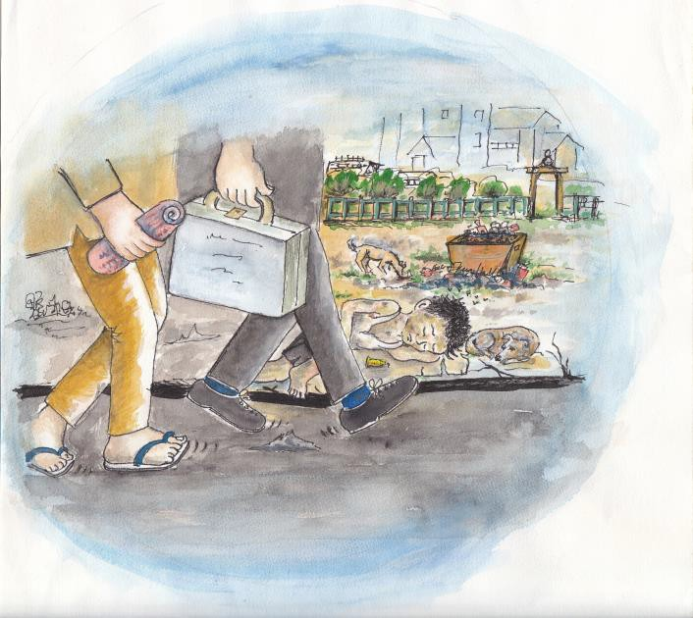

Child Protection Code of Conduct

  - Personal conduct and cultural considerations :

Individuals must respect local cultural norms, particularly:

Dress: Culturally appropriate dress is a required norm.
All are expected to dress professionally whenever on duty or visiting any work related activity or centre.
Alcohol: Alcohol is not to be consumed during office hours and never in office buildings. Residential staffs are not allowed to consume alcohol on working days.

Photographs, video and other images (see “ right of image” - guidelines also) :

YOU MUST

- Obtain the consent of the child and his/her parents or caretakers before taking photographs and images;
- Take and use photographs and images of children that are dignified and respectful and that do not present them as victims, vulnerable or submissive;
- Ensure children are adequately dressed in photographs and images and not in poses that could be interpreted as sexually suggestive;
- Protect the safety and privacy of children and their families by not using their images on the internet without explicit consent, or using them in any way which reveals their identity or location;
- Not use photographs and images of children to benefit financially other than for journalistic purpose.

If in doubt, please speak to a senior management team member.

Minimizing risk

NEVER

- Condone or participate in behaviour that is illegal or unsafe (it includes buying mobiles, cameras or any other materials from our program beneficiaries);
- Introduce visitors to the Center without prior clearance from the Center in-charge or a senior management officer;
- Exchange personal contact details with children.

TRY NOT TO

- Be alone with a single child, including in the following situations: in a car, overnight, in your home, or the home of a child;
- Show favouritism or spend excessive amounts of time with one child;

TRY TO

- Avoid placing yourself in a compromising or vulnerable position;
- Be accompanied by a second adult whenever possible (not for clinical staff, counselors);
- Meet with a child in a central, public location whenever possible (where there are other people);
- Avoid doing something that could be misinterpreted by a third party;
- Immediately record the details of any situation which may be misinterpreted;
- Not sleep close to unsupervised children unless absolutely necessary, in which case, obtain supervisor’s permission.

Where possible and practical, at least two adults, preferably one male and one female, should supervise all activities where children are involved and remain present at all times.

Sexual Behavior :

NEVER

- Develop physical/sexual relationships with a child
- Behave physically in a manner that is inappropriate or sexually provocative
- Engage in or allow sexually provocative games with children to take place
- Do things of a personal nature that a child could do for him/herself, including dressing, bathing, and grooming.

Physical behaviour :

NEVER

- Hit or otherwise physically assault or physically abuse a child. (see the point J for exceptional circumstances)
- Leave a child in the care of somebody who does not work for the organisation

DO NOT

- Develop relationships with children that could in any way be deemed exploitative or abusive
- Fondle, hold, hug, kiss or touch children in a culturally insensitive way
- Smoke or drink alcohol in the presence of children or ask children to buy tobacco or alcohol for you.

Psychosocial behavior :

DO

- Be aware of the power balance between an adult and child, and avoid taking any advantage this may provide.

DO NOT

- Use language that will mentally or emotionally harm a child – teasing, bullying, name calling, for example
- Use language, make suggestions or offer advice that is inappropriate, offensive or abusive
- Do anything that could humiliate a child
- Suggest inappropriate behavior or relations of any kind
- Act in any way that intends to embarrass, shame, humiliate or degrade a child
- Encourage any inappropriate attention seeking behavior, such as tantrums by a child
- Show discrimination of race, culture, age, gender, disability, religion, sexuality, or political persuasion.

Peer Abuse :

DO

- Be aware of the potential for peer abuse
- Develop special measures/supervision to protect younger and especially vulnerable children
- Avoid placing children in high-risk peer situations (e.g. unsupervised mixing of older and younger children).

DO NOT

- Allow children to engage in sexually provocative games with each other.

Physical Environment :

DO

- clear rules to address specific physical safety issues relative to the local physical Develop environment of a project (e.g. for projects based near water, heavy road traffic, railway lines).
- Keep the things that may result in any kind of danger away from the reach of the children,
e.g. poisons, matches, gas stoves, explosive objects, weapons, chemicals, etc…
.

Action to take if you hear about, suspect or witness or are told of an abuse/ potentially abusive behavior :

Immediately bring to the attention of the partner (this may not always be appropriate) and your own line manager any instance of witnessed or suspected abuse, and any action or behaviour that could be construed as poor practice or potentially abusive.

Please refer to your Reporting Concerns Framework (below)

- Physical confrontation with a child/youth :

Despite we well know this point may seem controversial, CPCS do recognise the reality of violence suffered by street based children and youth. CPCS understand the exceptional need of a physical response and right to retaliate if and only if :

A staff, volunteer or board member is physically attacked and his/her integrity is under threat. A staff, volunteer or board member is assaulted or insulted on gender base issue.
A staff, volunteer or board member (including their family members and properties) is severely threatened.

DO
- Try to limit as possible the use of physical violence
- Inform other team members as soon as possible
- Try to cool down the child/youth

NEVER

- Retaliate further using external persons apart duly habilitated police officers
- Risk your life for CPCS properties
- Forget to report as soon as possible

Action to take if you are involved in any kind of violent confrontation with a child or a youth :

Immediately report to the center in charge and report officially using the form down. Be aware that the report is compulsory and that a enquiry will be done immediately.

REPORTING CONCERNS FRAMEWORK

If you are concerned about the safety and welfare of a child you must follow this procedure;

What are the circumstances of your concern?

Did you witness child abuse? Yes/No
Do you suspect someone of child abuse? Yes/No
Has someone alleged abuse of a child? Yes/No Has someone disclosed abuse of a child to you? Yes/No

Does your concern fit any of the following categories of abuse?

Do you think a child may have been neglected? Yes/No Do you think a child may have been physically abused? Yes/No
Do you think a child may have been emotionally abused? Yes/No Do you think a child may have been sexually abused? Yes/No

Your concern is justified if you answered yes to any of the questions above, your duty is to report your concerns to one of the following persons, don’t delay - a child may be at risk of serious harm if you do;

  - First Contact person = Your direct supervisor (Program in charge). He will then follow the info to the Child Protection Officer.

  - If unavailable or involve, please report to :

Name: Badri Prashad Sharma
Title: Child Protection officer
Location: Godawari - Lalitpur

If you have concerns about informing the person in this box please feel free to advise the person in the following box.

  - or (Contact person) :

Name: Bijesh Shrestha Title: Program Director
Location: Godawari - Lalitpur

This person will examine the information and, if considered necessary, agree emergency steps and an action plan with timings and responsibilities for the field

Guidelines for reporting suspected or actual abuse of Children

Reporting under the policy can be summarized as follows:

- Where the alleged perpetrator is a CPCS Staff, board member, youth, volunteer or Visitor, all child protection concerns and breaches of CPCS‟s Child Protection Policy must be reported.

- Where the alleged perpetrator is outside the scope of the policy (i.e. none of the above) only child protection concerns relating to sexual abuse and exploitation and concerns and abuse which suggests a crime has been committed as per the local legislation and other serious forms of abuse should be reported.

The above reporting requirement ensures that CPCS never ignore serious forms of abuse and crimes perpetrated against children regardless of whom the perpetrator might be and ensures that we address any form of abuse or exploitation within our own activities.

Within each center, the center in charge is designated for dealing with breaches of the Child Protection Policy. If you have a concern you may make a report to him/her and/or to the Child Protection Officer. They will then take further action to ensure that the issue is addressed and appropriate referrals are made in line with local procedures.

Employees, volunteers or any other persons inside CPCS Centers or activities must immediately report any suspected or actual child abuse. No CPCS staff or partner will prejudice their own position by responsibly reporting anyone who they believe is breaking the Child Protection Policy and Code of Conduct.

If your concerns involve immediate significant harm to a child, act without delay, as inaction may place the child in further danger.

Immediately inform your direct authority. If you are unwilling to do so, contact without delay the Child Protection Officer and fulfill the form. Confidentiality will be maintained.

Your supervisor or the Child Protection Officer will focus on :

-Finding evidence that the Child Protection Policy and code of Conduct has been broken.
-Identifying further risks to the child/children concerns.
-Taking necessary actions.

CPCS

Personnel training and Recruitment Procedure

CPCS will encourage opportunities to question and learn about child protection issues. The Child Protection Officer and the management will promote a positive culture encouraging openness and transparency regarding child protection issues. Basic orientation and trainings will be conducted regularly and information will be shared with the program beneficiaries.

The procedure of recruitment for all employees, consultants, volunteers, whether paid or unpaid, full time or part time, temporary or long-term includes :

  - A declaration of commitment and understanding of the CPCS Child Protection Policy and Code of Conduct.

  - A personal declaration of criminal convictions. Police reference may be requested for the final candidate.

  - Minimum 2 character referees from individuals who have more than 2 years relationship with the applicant.

  - During interviews, direct questions related to child protection will be include.

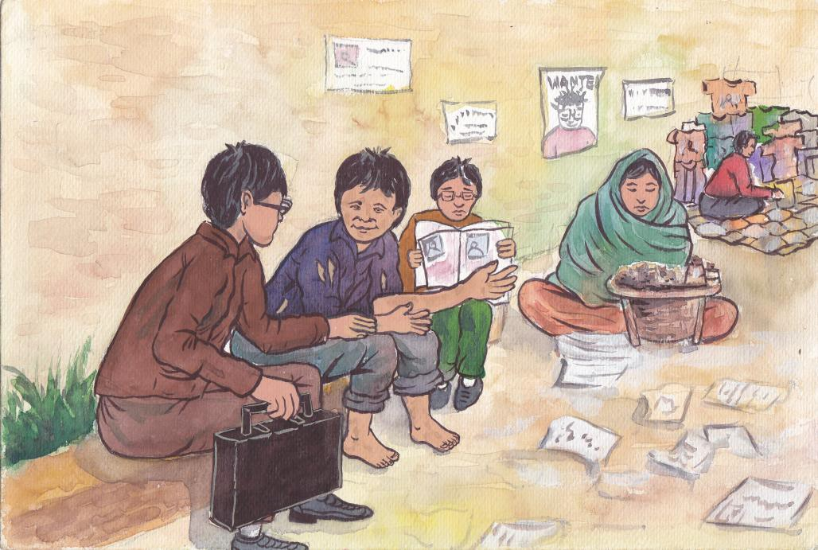

Report form for suspected abuse
Your Name : | Your Designation :
Type of abuse : physical - moral - sexual
Suspected person (s) and designation :
Name and code of the suspected victim (s) :
Location, date and time of the suspected abuse :
Any other witnesses (Name and designation) :
Explain in details :
How did you react ?
Report transmitted to on
Your Sign :

Report form for physical confrontation with a child or a youth
Your Name : | Your Designation :
Name (s) of the children involve :
Date and time of the confrontation :
Location of the confrontation :
Any other witnesses (Name and designation) :
Explain in details (including how the child threat you and how you react) :
How did you react and have you speak with the child afterwards ?
Report transmitted to on
Your Sign :

CPCS

“Right of image” Guidelines

Images, photos, personal stories...

If you wish to take images or to report by any form the personal story of a child, for personal or professional use, you must always first consult with the Center In Charge to ensure that it is ok to take pictures and that the intended use of the pictures does not conflict with CPCS’s policies on protecting children.

Where the in charge confirms that it is ok to take pictures or to record a child story, you must follow the following requirements:

Inform children (or in the case of young children, their parent or guardian) of the purpose, ask their permission and respect their decision to say no.

This means:

Always ask permission before taking images and inform them of the specific purpose(s) for which images are intended to be used (including how, when and where it will be used) so they can make an informed decision giving full consideration to their capacity to do so..

Always make clear that there will be absolutely no negative repercussions from denying such consent.

Respect the decision of child or their parents/guardians to say no or to change their mind to an image being taken or to object to the use of the image at any stage of the process i.e. before, during and after it has been taken.

Ensure images are respectful and do not impact negatively on their dignity or privacy Ensure that any images taken of children are respectful (For example: children should have adequate clothing that covers up their sexual organs. Images of children in sexually suggestive poses or that in any way impact negatively on their dignity or privacy are not acceptable).

Ensure that use of images does not put the child at risk of being identified or located This means that the use of an image should not lead to the child and/or their location being identified:

Any information which could lead to the identification of the child their families and/or their location being identified should not be used in conjunction with the image.

Ensure that the content of the image does not contain any details which may lead to the identification of the child. For example, names of schools, names of street etc. these should be blurred out.

Do not publish images on social media or any other media

Additional guidance for Ethical Journalism

When taking photographs or writing about children, the following points must be considered :

- Individuals must not be identifiable so that any third party will not be able to make a link between the child and the photo or story.

- The child and their caregiver must give their consent.

- Never pay money to take a photograph or record a story.

Best Practice :

- Remember street based children and children at risks have rights and feelings just like you.

- Capture images and stories showing children doing good things or staying out of trouble.

- Are you drawing a positive attention to street based children or other children cared by CPCS ?

- Avoid stereotyping street based children as only using drugs, begging or sniffing glue.

- Taking images not showing the child face will still enable you get communicate your story.

- If it is absolutely necessary to use recognizable images, you must obtain a clear consent beforehand.

In the spirit of Journalism :

Whether you are a journalist, a staff, a volunteer, a tourist reporting the daily life of Nepal, we suggest you to adopt the Spirit of journalism in your approaches to street children or any other children supported by CPCS. Ask yourself the following questions :

- Does my photographs or stories portray the children’s issues more accurately, with greater depth ?
- Have the children contributed to the story or the way an image is taken ?
- Have I portrayed children as helpless sufferers, unable to act, think or speak for themselves ?
- Have I used stereotypes such as starving children, irresponsible teenagers ?
- Have I used fair, open and straightforward methods of obtaining pictures or record stories ?
- Would I have allowed some stranger to do what I have just done to myself or my children ?

CPCS

Child Protection Policy (including the code of conduct)

Declaration

I have read the code of conduct. I understand it to be an essential component of our Child Protection policy and that this policy is available for me to read in full.

I declare that I have had every opportunity to discuss both the code of conduct and the Child Protection policy with an organizational representative.

I declare that I understand the CPCS Child Protection Policy and code of conduct, and agree to comply with it.

Signed Position Date

